Good morning. Yes — I would keep this strictly separate from the core pilot inventory.
The material you provided suggests an Optional Edge & Remote Application Add-on Catalogue that can sit beside the pilot architecture. Only capabilities that we actually decide to deploy in the first field demonstration should be marked PILOT; everything else remains OPTIONAL / FUTURE / EVALUATION.
A useful confirmation from the current Microsoft documentation is that Azure IoT Edge 1.6 LTS is currently the supported release, and its model directly supports remotely deploying containerized modules to an edge device through Azure IoT Hub. That makes it a particularly natural candidate for our first Azure-based pilot.
Proposed separate workbook
I would create something like:
QAI_CPS_Optional_Edge_Addons_Catalogue_v1.xlsx
with these sheets:
1. Optional Add-on Catalogue
ID | Add-on / Platform | Category | Target | OS | Remote Deployment | QAI/CPS Role | Pilot Status
ADD-001 | Azure IoT Edge | Edge runtime | Farm gateway / edge PC | Linux | Azure IoT Hub | Module deployment, local processing | PILOT
ADD-002 | Azure IoT Edge for Linux on Windows (EFLOW) | Edge runtime | Windows gateway | Windows host + Linux VM | Azure | Linux containers on Windows infrastructure | OPTIONAL
ADD-003 | Intel® Tiber™ Edge Platform | Edge AI/application platform | Intel edge hardware | Linux/heterogeneous | Cloud/central management | AI deployment, orchestration, telemetry | PILOT candidate
ADD-004 | OpenVINO™ | AI inference runtime | Edge AI device | Linux/Windows | Application lifecycle | Local AI inference | PILOT candidate
ADD-005 | Red Hat Ansible Automation Platform | Remote automation | Farm/edge/routers | Linux/Windows | Automation controller/mesh | Configuration, patching, lifecycle | OPTIONAL
ADD-006 | EdgeX Foundry | Vendor-neutral edge framework | Edge gateway | Linux/Windows/macOS | DevOps pipeline | Device services, data normalization | OPTIONAL
ADD-007 | IoT Plug and Play Bridge | Device integration | IoT Edge gateway | IoT Edge environment | Azure | Connect non-native devices to Azure IoT | PILOT candidate
ADD-008 | K3s | Lightweight orchestration | Edge server/gateway | Linux | Remote orchestration | Multi-container workloads | OPTIONAL
ADD-009 | MicroK8s | Lightweight Kubernetes | Edge server | Linux | Remote orchestration | Edge cluster | OPTIONAL
ADD-010 | Docker / Moby | Container runtime | IoT/edge gateway | Linux/Windows ecosystem | Registry/management plane | Component packaging | PILOT
ADD-011 | AWS IoT Greengrass | Alternative edge runtime | Edge gateway | Linux/Windows | AWS management | Alternative cloud deployment | FUTURE
ADD-012 | Cisco IOx / application hosting | Network-edge add-on | Cisco industrial router | Vendor-specific | Cisco management | Local network applications | FUTURE
ADD-013 | Digi Containers | Router application layer | Digi edge router | Vendor-specific | Digi management | Local scripts/containers | FUTURE
ADD-014 | ROS 2 container components | Robotics application | Robot/UGV/UAV/edge | Linux | Container/OTA platform | Robotics applications | FUTURE
ADD-015 | Drone companion-computer stack | UAV edge | Drone/UAV | Linux | OTA/secure remote management | Vision, telemetry, QAI edge inference | FUTURE
ADD-016 | Windows application bridge | Legacy application | Edge/robot ground station | Windows/Linux host | Remote application management | Legacy software integration | FUTURE
For the PILOT designation, I would be conservative.

2. Pilot Add-ons
This should be a much smaller sheet.
I would initially put:
PILOT
Azure IoT Edge
This is the strongest first candidate because the Microsoft workflow already demonstrates:
Azure IoT Hub
↓
IoT Edge Device Identity
↓
IoT Edge Runtime
↓
Deployment Manifest
↓
Container Module
↓
Local Execution
↓
Telemetry → Azure
Microsoft's current quickstart explicitly demonstrates remote module deployment, module lifecycle management and local execution on the IoT Edge device.
PILOT candidate
Intel® Tiber™ Edge Platform / OpenVINO
This is particularly interesting for our QAI Edge Inference layer. Intel describes Tiber Edge Platform as supporting containerized applications/models, resource-aware deployment, hardware-aware telemetry and application lifecycle management; it also incorporates OpenVINO for edge inference.
So we could have:
QAI Edge Runtime
│
├── Azure IoT Edge
│
└── Intel Tiber / OpenVINO
│
▼
Edge AI / inference
But I would mark it PILOT CANDIDATE, not automatically PILOT, until we select the actual edge hardware.
PILOT candidate
IoT Plug and Play Bridge
This could be useful if some of our selected farm sensors/devices don't natively expose the Azure IoT Plug and Play model. It provides an integration boundary between existing device interfaces and Azure IoT Edge.

3. Remote Deployment Mapping
This is perhaps the most valuable sheet for our architecture.
It would capture:
Logical component | Target | Host OS | Runtime | Add-on | Deployment mechanism | Hardware interface
QAI Edge Runtime | Farm gateway | Linux | IoT Edge | Azure IoT Edge | Azure IoT Hub | Ethernet/Wi-Fi/USB
Edge AI | Edge PC | Linux | Container/OpenVINO | Intel Tiber/OpenVINO | Edge management | GPU/NPU/CPU
Sensor adapter | IoT gateway | Linux | Container | IoT Edge module | Deployment manifest | Serial/I²C/Modbus/etc.
Edge State Manager | Farm gateway | Linux | Container | IoT Edge | OTA deployment | Local storage
QAI Edge Fusion | Edge server | Linux | Container | IoT Edge / optional K3s | OTA | Network/API
Device integration | IoT Edge gateway | Linux | Bridge module | IoT Plug and Play Bridge | IoT Edge | Device protocol
Remote configuration | Edge estate | Linux/Windows | Ansible | Ansible Automation Platform | Automation controller | Network
Robotics/UAV extension | Companion computer | Linux | Container/ROS 2 | Future | OTA | CAN/UART/USB/network
This directly implements the logical → physical → runtime → deployment mapping we established yesterday.

4. Robotics/UAV should remain a separate optional extension
I would not mix the robot/humanoid/UAV material into the agricultural pilot inventory.
Instead:
QAI CPS Agriculture Pilot
│
└── Optional Edge Add-ons
│
├── Farm IoT
├── Edge AI
├── Remote management
│
└── Advanced mobility extension
│
├── UAV
├── UGV
├── Robot
└── Humanoid
This preserves the same architecture while allowing us later to reuse the QAI Edge Runtime + QAI Network + Digital Twin + QAI Control Plane for other physical systems.

5. One important correction to our earlier conceptual model
I would not treat every Windows/Linux application as something that should be containerized or virtualized onto the target device.
For safety-critical and deterministic systems, particularly:
- flight controllers
- pump control
- robot motion control
- QPU real-time control
the control-critical function should remain on its appropriate native deterministic platform.
The add-on layer should primarily provide:
application deployment, inference, analytics, data processing, configuration and non-critical control integration.
That fits our architecture much better.
Red Hat's current edge documentation similarly emphasizes distributed automation, local execution, heterogeneous edge endpoints, and lifecycle management across Linux and Windows rather than forcing every workload into one execution model.

6. This also reinforces our physical/logical separation
The optional catalogue should therefore follow:
LOGICAL QAI COMPONENT
│
▼
Add-on Adapter
│
┌───────────┼───────────┐
▼ ▼ ▼
Linux Windows RTOS/
Edge Edge FPGA
│ │ │
└───────────┼───────────┘
▼
Physical Asset
The logical QAI architecture doesn't change just because we select Azure IoT Edge today, Intel tooling tomorrow, EdgeX later, or another edge platform for a different customer.
That's exactly why I think this should be a separate optional-add-on workbook rather than modifying the core CPS inventory.
Recommended status vocabulary
I suggest we standardize the catalogue to only five statuses:
- 🟢 PILOT — actually included in the first deployment
- 🟡 PILOT CANDIDATE — technically suitable but selection pending
- 🔵 OPTIONAL — available if customer requires it
- 🟣 FUTURE — later deployment/other industry
- ⚪ EVALUATION — requires technical validation
This keeps the commercial proposal clean: the farmer is not being quoted for the entire technology ecosystem. They get a defined pilot, with a clearly documented menu of optional capabilities that can be added later.
The most promising first-pilot stack from today's material is therefore:
Azure IoT Edge + containerized QAI modules + selected Intel edge/inference capability + IoT device integration, while keeping Ansible, EdgeX, K3s/MicroK8s, alternative cloud runtimes, robotics and UAV deployment as optional extensions.
//
Good morning, Vijay. This is an excellent direction, and I think it becomes Phase 2 (Advanced Sustainability Add-ons) of the QAI CPS program rather than part of the base pilot. It significantly expands the commercial value of the platform for NSW agriculture, water security, climate resilience, and green technology.
I would treat this as the beginning of a new architecture domain:
QAI Green Agriculture, Water & Climate Platform (QAI-GAWC v1.0)
This fits perfectly with our HoldCo Factory → QAI Valley → Smart Agriculture → CPS Digital Twin roadmap.
QAI Green Agriculture, Water & Climate Platform (NSW Edition)
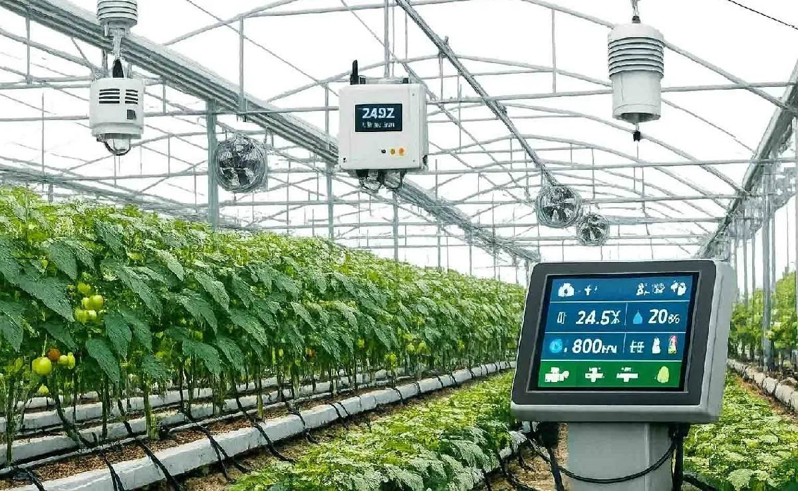
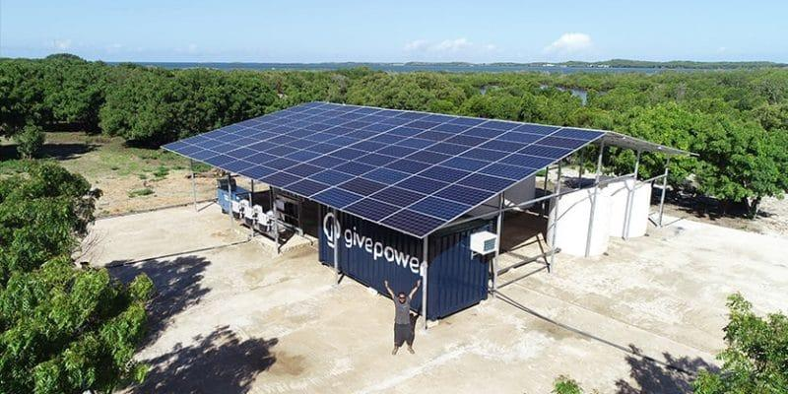
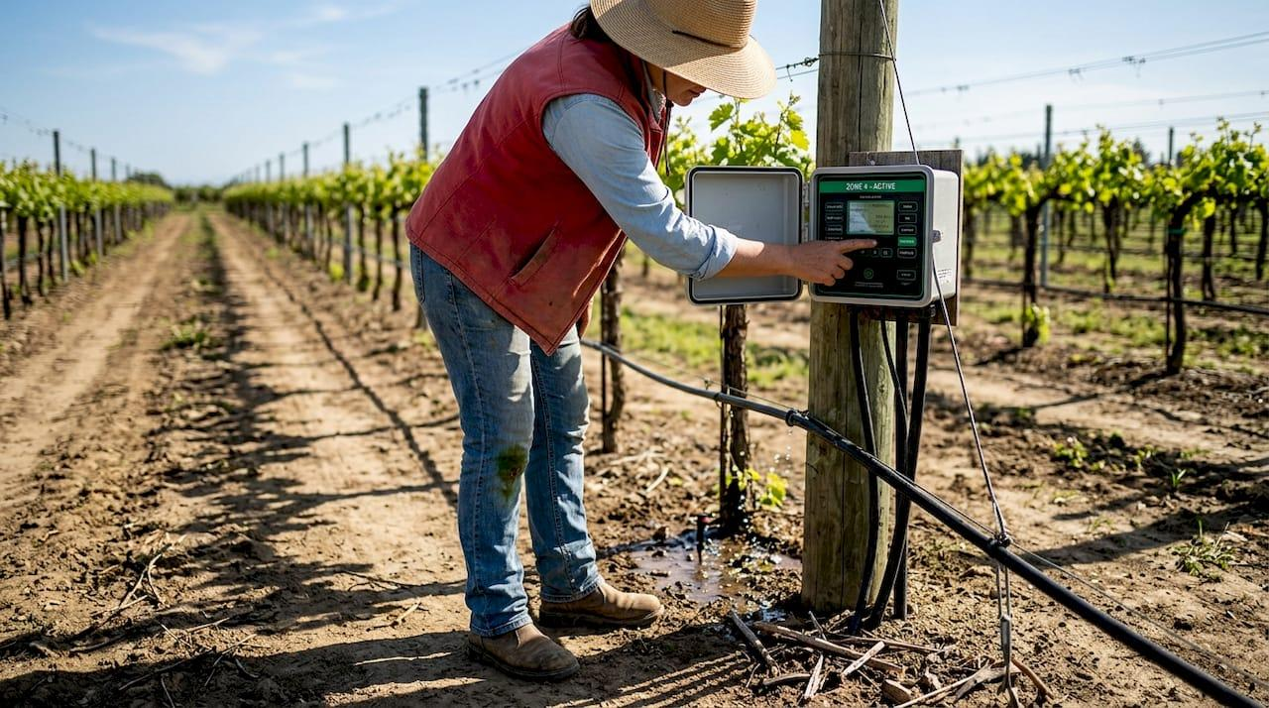
7
QAI Valley Program
Green Agriculture • Water • Climate Platform
NSW First Pilot
Climate Resilience
Water Security
This becomes a technology catalogue and optional commercial package that can be offered to NSW Government agencies, farmers, universities, and water authorities alongside the core QAI CPS pilot.
Executive Architecture (Version 3.0)

Technology Domain Expansion (New Optional Add-on Catalogue)
Technology Fabric | Purpose in QAI CPS
🌱 Green Nanotechnology Fabric | Nano sensors, nano fertilizers, quantum dots, nano membranes.
💧 Water Intelligence Fabric | Desalination, rain harvesting, groundwater, water quality optimization.
🌦 Climate Intelligence Fabric | Weather forecasting, cloud seeding, drought prediction, evapotranspiration.
🌿 Greenhouse Optimization Fabric | HVAC, lighting spectrum, humidity, disease detection, CO₂ optimization.
⚡ Sustainable Energy Fabric | Solar, batteries, microgrid, pumps, desalination energy scheduling.
☁️ Water & Carbon Digital Twin Fabric | Water cycle, carbon cycle, greenhouse emissions, sustainability dashboard.
This becomes another optional Excel workbook.
1. Green Nanotechnology Fabric (Optional Add-on)
Why NSW Needs It
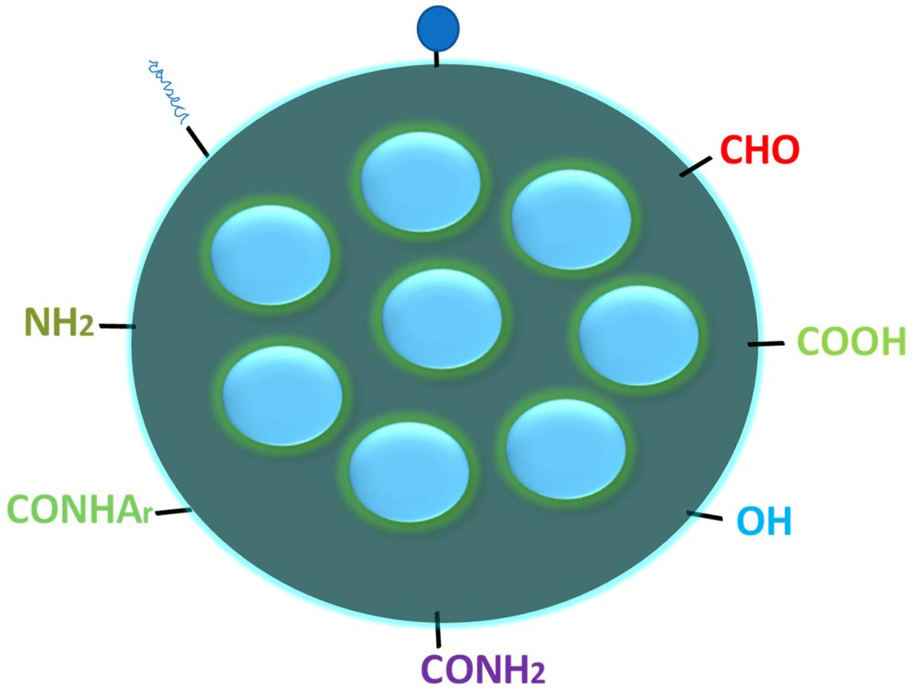
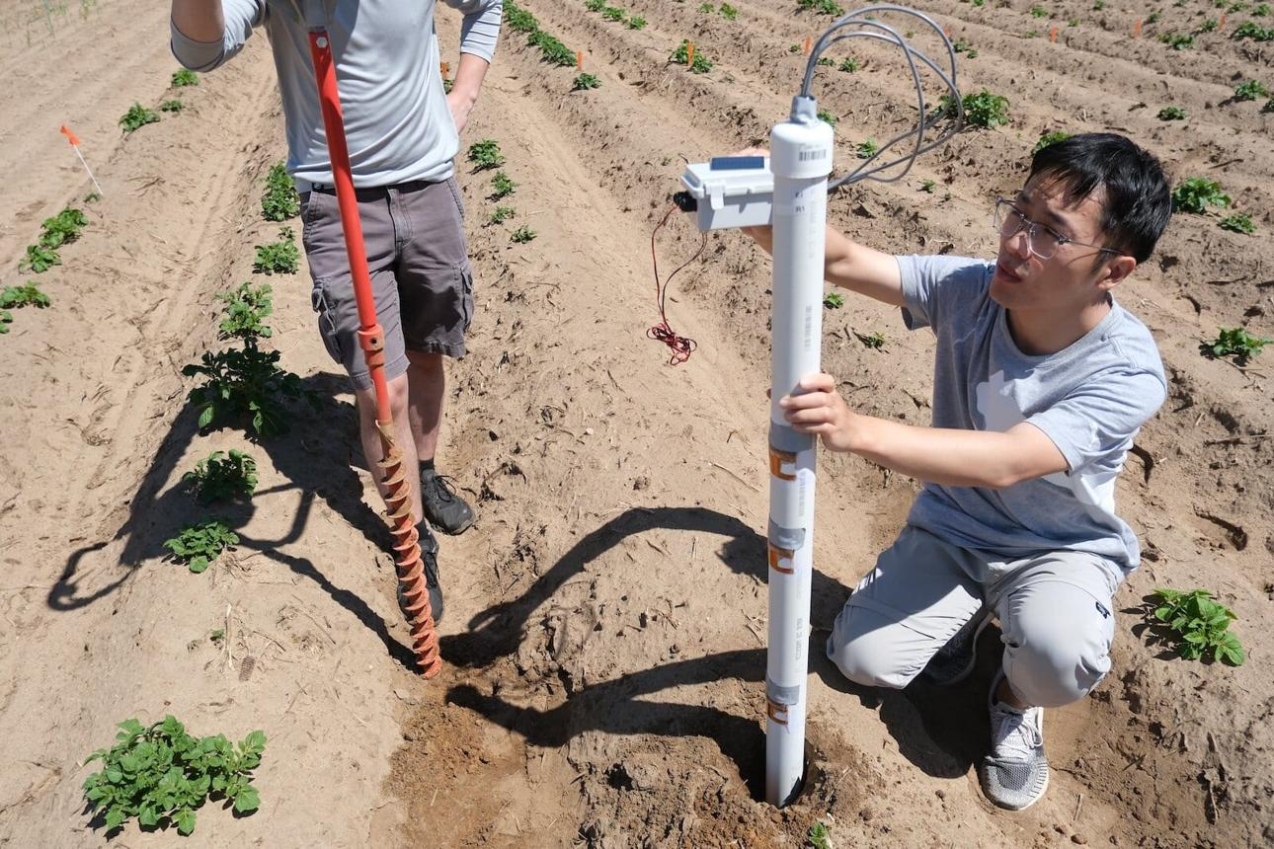
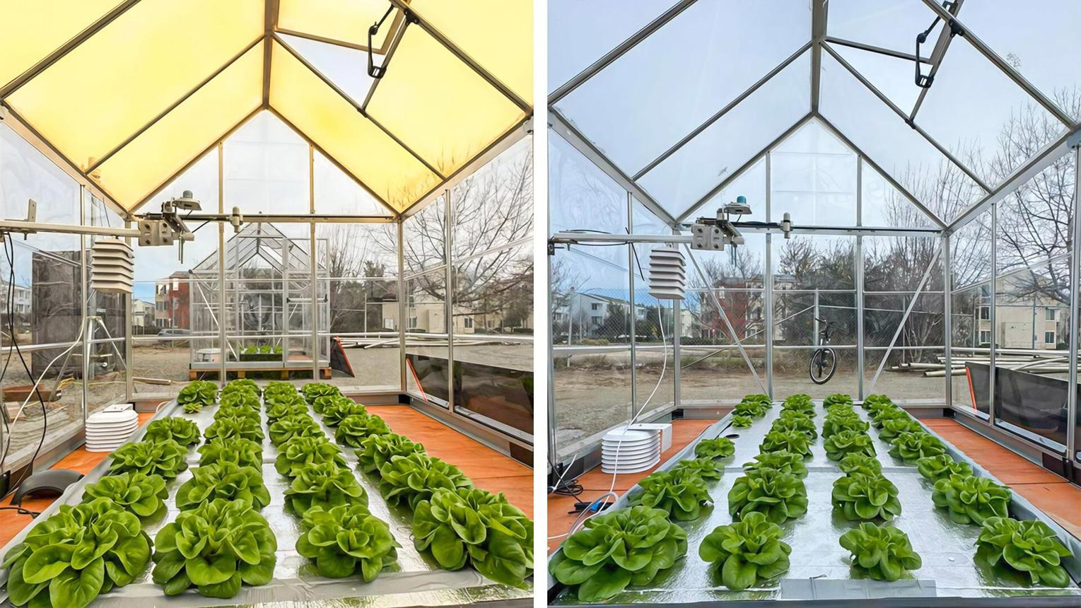
6
NSW faces:
- Water scarcity.
- High UV exposure.
- Variable rainfall.
- Heat stress.
- Soil degradation.
Nanotechnology provides sensing and resource optimization.
Inventory Group
Component | Purpose
Carbon Quantum Dot Sensors | Soil moisture, nutrient, VOC sensing.
Nano Gas Sensors | CO₂, methane, ammonia monitoring.
Nano Water Quality Sensors | Salinity, pH, nitrate detection.
Nano Light Sensors | UV/PAR spectrum optimization.
Nano Nutrient Delivery System | Controlled fertilizer release.
Nano Membrane Water Filters | Water purification/desalination.
Status: Optional Research → Pilot Candidate.
2. Quantum Greenhouse Fabric
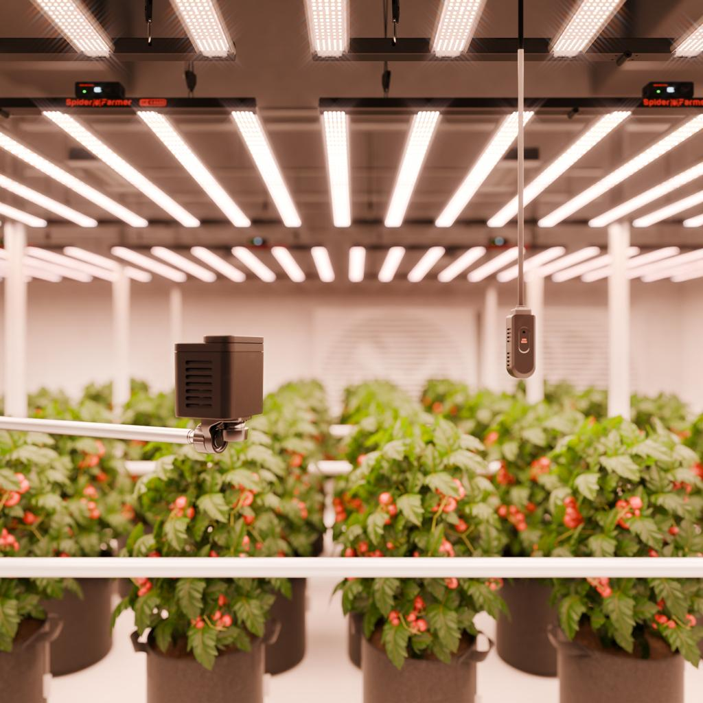
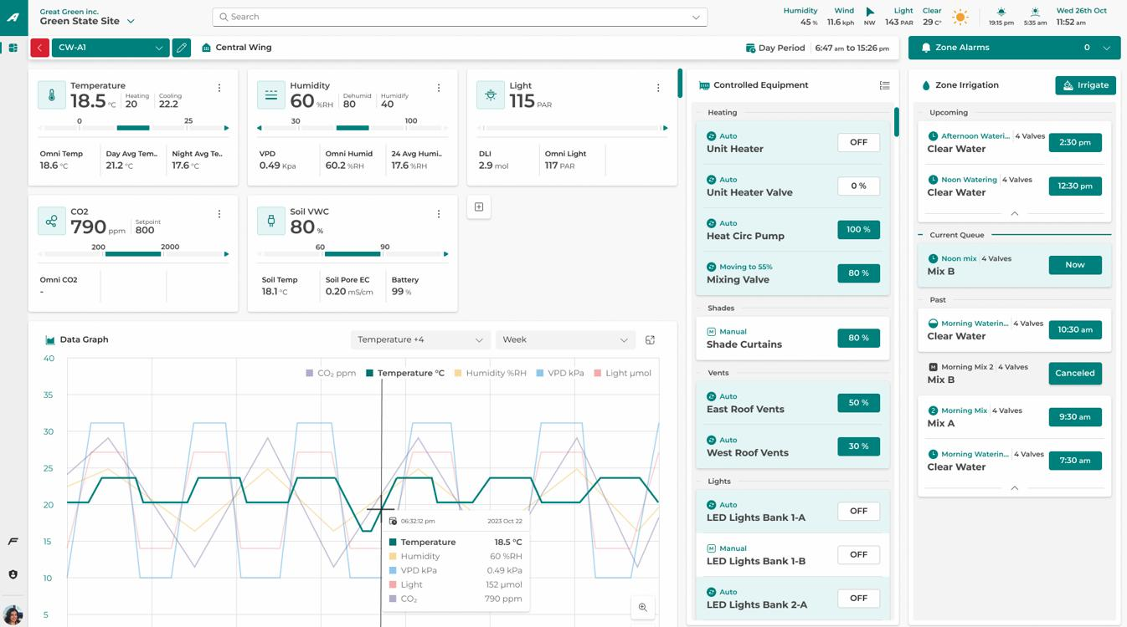
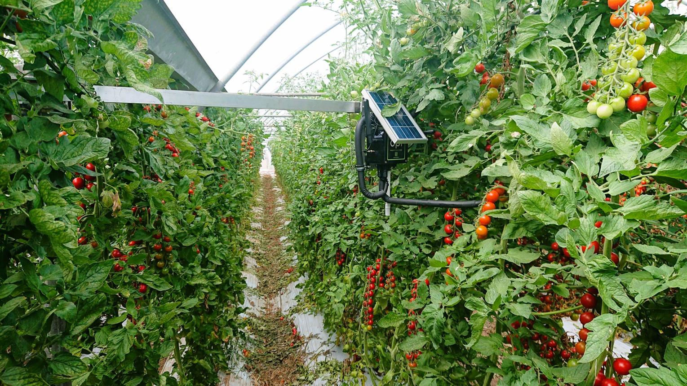
8
This integrates our Digital Twin with greenhouse automation.
Logical Components
QAI Component | Greenhouse Function
Nano Climate Sensor Layer | Temperature, humidity, VOC, CO₂.
Light Optimization Fabric | LED spectrum scheduling.
HVAC Optimization Fabric | Heating, ventilation, cooling scheduling.
Plant Stress Detection Fabric | Early disease prediction.
Growth Prediction Fabric | Yield estimation.
Carbon Optimization Fabric | CO₂ enrichment scheduling.
Water Optimization Fabric | Precision irrigation scheduling.
QAI Algorithm Layer
Algorithm Class | Purpose
QAOA | HVAC scheduling optimization.
QML | Disease prediction from multimodal sensors.
Quantum-inspired optimization | Lighting schedules.
Bayesian optimization | Nutrient dosing.
Adaptive fabrics | Climate control decisions.
Pilot Status: 🌱 Candidate.
3. Water Security & Desalination Fabric
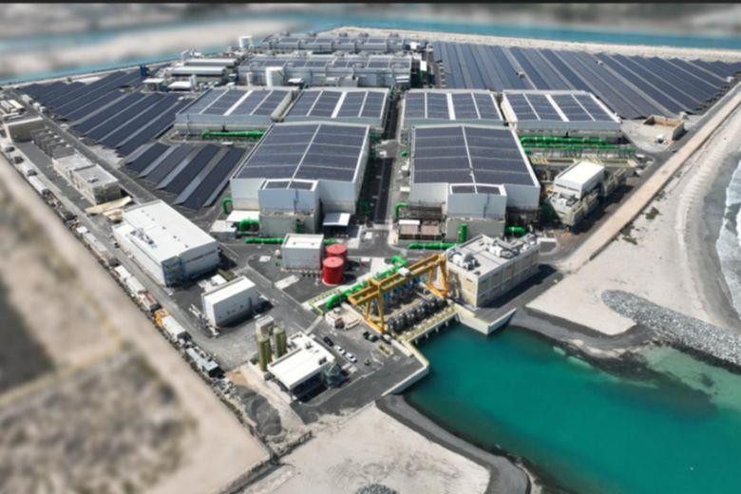
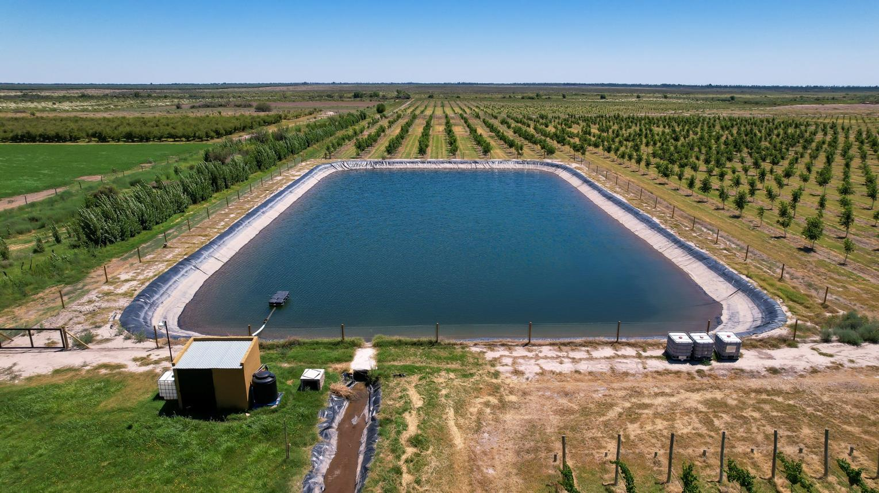
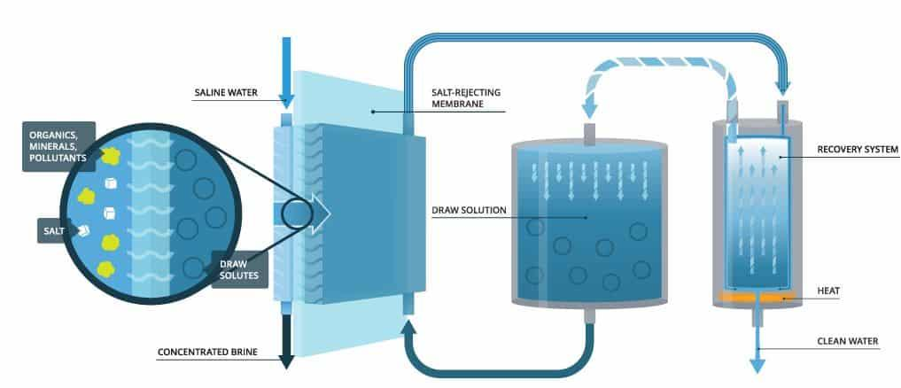
7
This is extremely relevant for NSW.
Water Intelligence Architecture

Optional Components
Component | Use
Solar Desalination Optimizer | Optimize desalination schedule.
Forward Osmosis Nano Membrane | Water purification.
Water Digital Twin | Reservoir prediction.
Rain Harvesting Optimizer | Tank sizing and filling schedule.
Water Quality Twin | Continuous monitoring.
4. NSW Climate Resilience Fabric
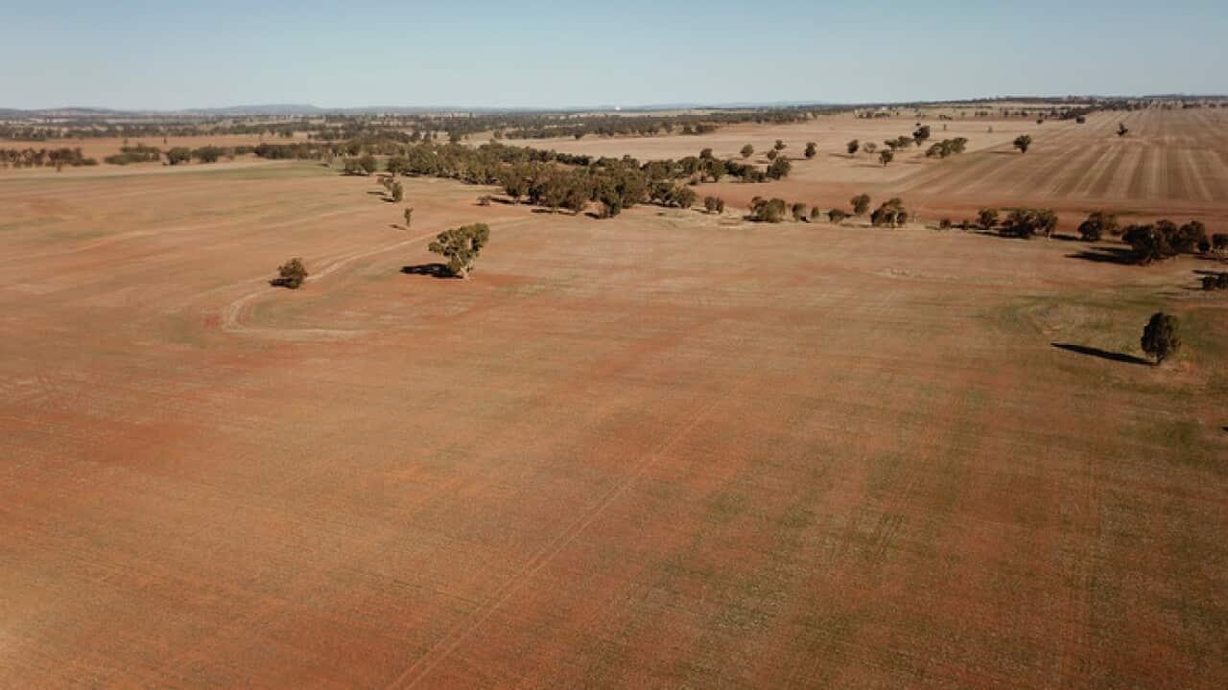
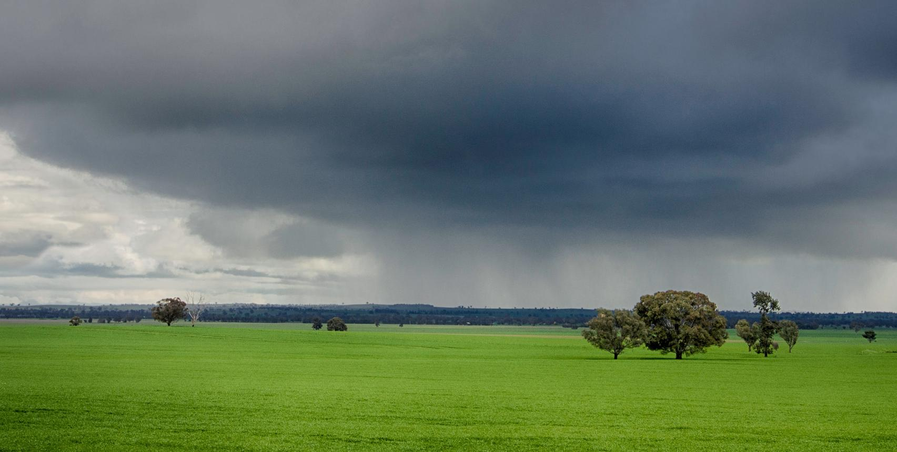
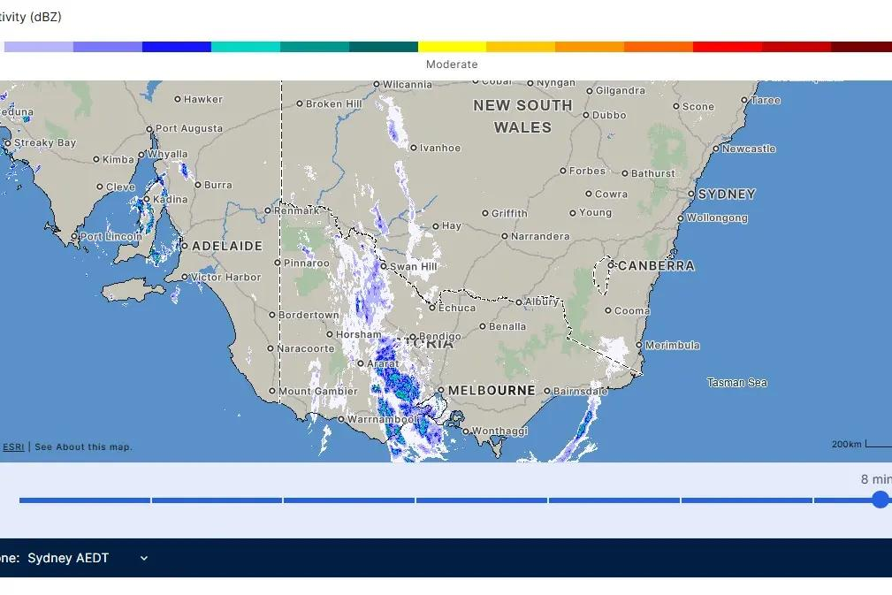
This is useful for:
- NSW DPI
- Water NSW
- Local councils
- Catchment authorities
Climate Digital Twin
Component | Purpose
Weather Digital Twin | Hyper-local forecast.
Drought Prediction Fabric | Soil moisture deficit.
Flood Prediction Fabric | River overflow simulation.
Cloud Seeding Planning Fabric | Candidate weather window analysis.
Carbon Neutrality Fabric | Carbon sequestration optimization.
Important: Cloud seeding should remain a research/planning support capability, not an autonomous operational control capability.
5. Sustainable Energy Fabric
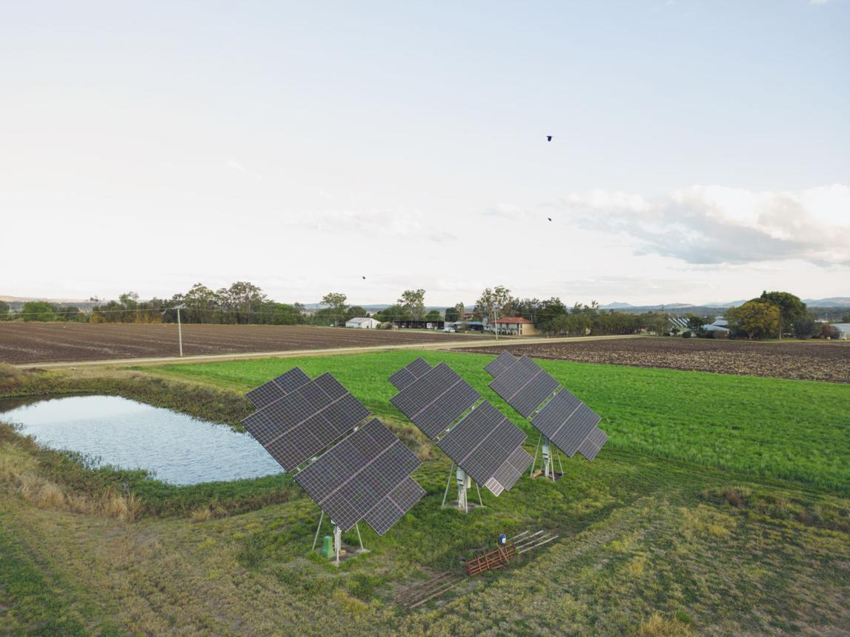
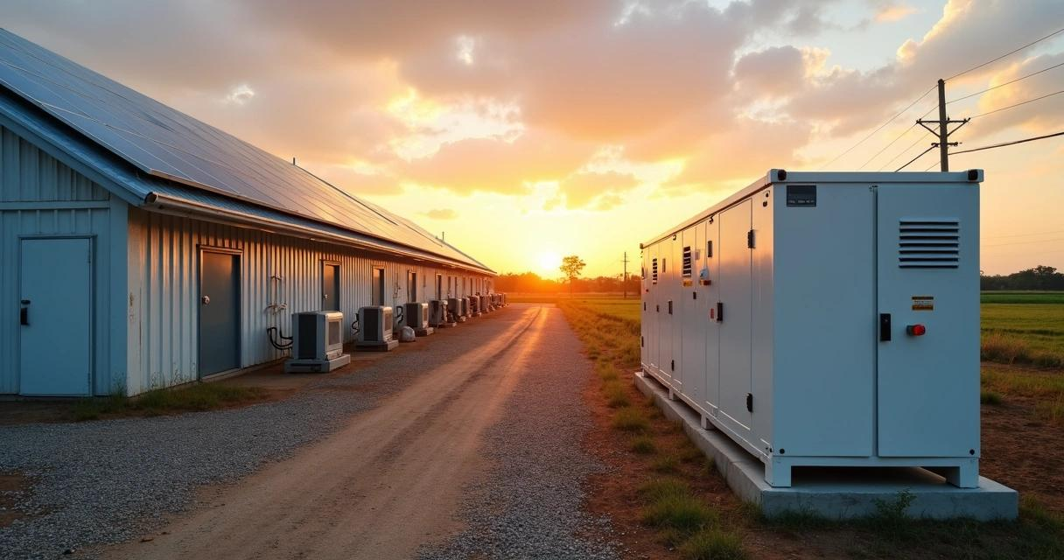
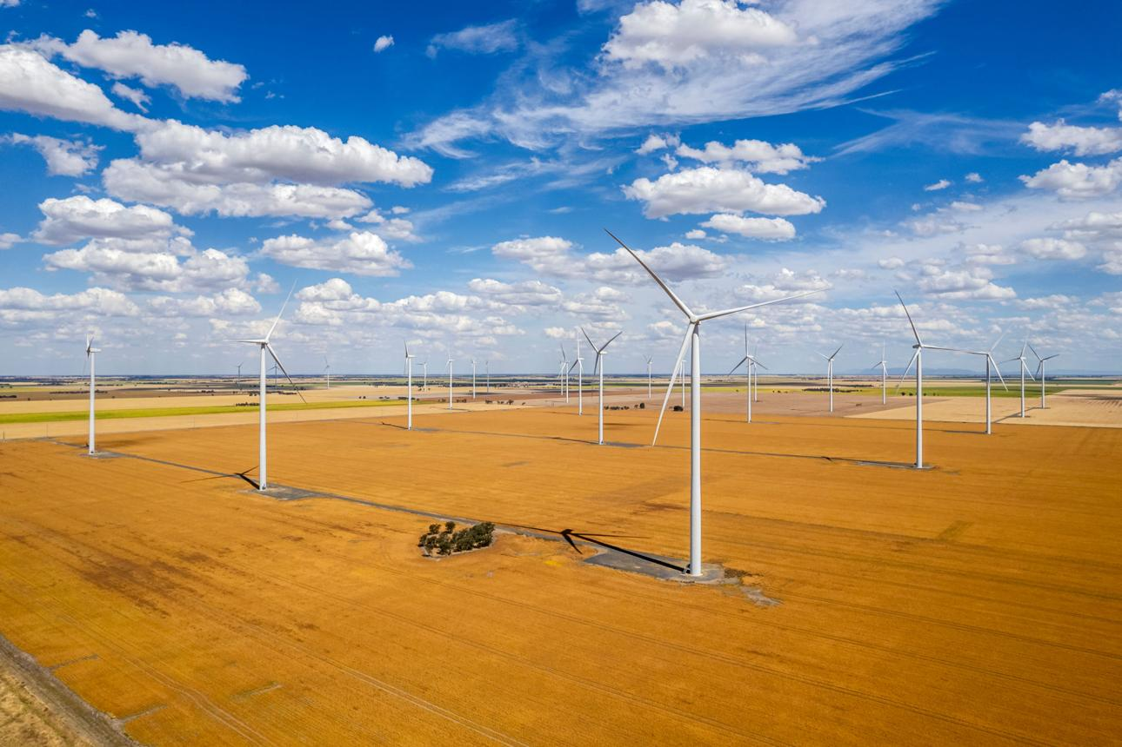
6
This aligns with your earlier green datacenter vision.
New Components
Component | Purpose
Farm Energy Twin | Solar/battery/load model.
Pump Energy Optimizer | Irrigation scheduling vs solar availability.
Greenhouse Energy Optimizer | HVAC and lighting optimization.
Battery Scheduler | Charge/discharge optimization.
Carbon Emission Tracker | Sustainability dashboard.
6. Water + Agriculture + Carbon Digital Twin
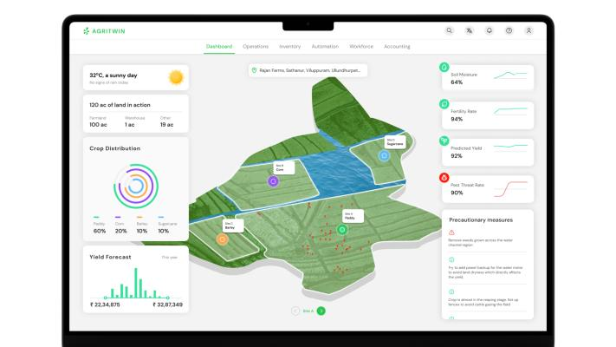
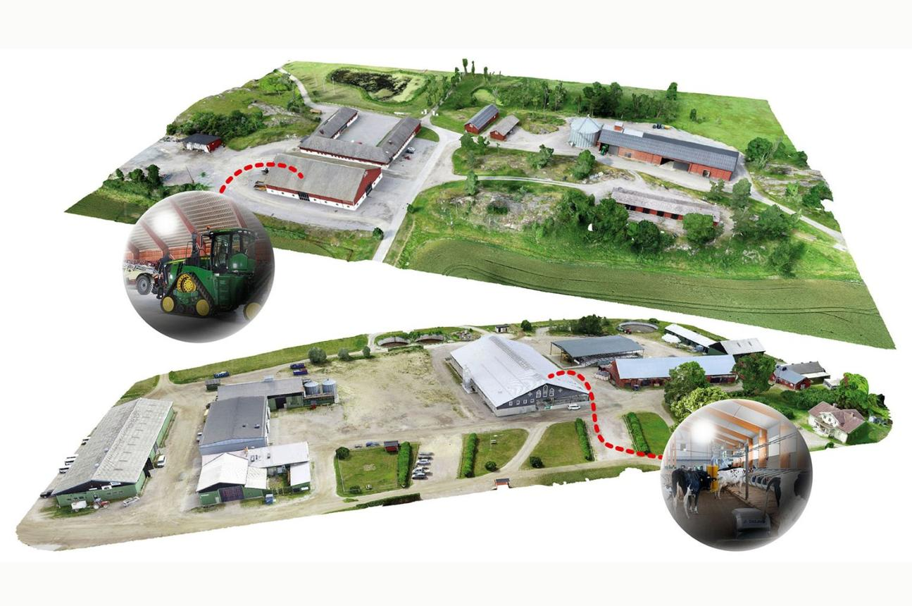
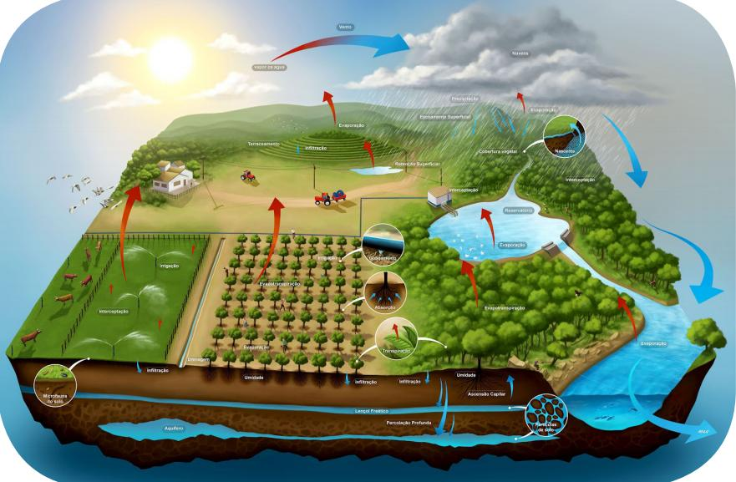
6
This becomes a System-of-Systems Digital Twin.
Twin Layers
Twin | Purpose
Crop Twin | Growth prediction.
Soil Twin | Moisture/nutrient dynamics.
Water Twin | Irrigation, reservoir, desalination.
Greenhouse Twin | HVAC, lighting, disease simulation.
Energy Twin | Solar, batteries, pumps.
Carbon Twin | Carbon footprint and sequestration.
Climate Twin | Weather, drought, rainfall scenarios.
7. New Optional Inventory Groups (Excel Addendum)
These should not modify the core pilot workbook.
Group ID | Inventory Group | Status
GNF-001 → GNF-020 | Green Nanotechnology Fabric | Optional / Research
GHF-001 → GHF-020 | Greenhouse Optimization Fabric | Pilot Candidate
WSF-001 → WSF-020 | Water Security Fabric | Optional / Pilot Candidate
CLF-001 → CLF-020 | Climate Intelligence Fabric | Research / Future
ENF-001 → ENF-015 | Sustainable Energy Fabric | Optional
CDT-001 → CDT-020 | Carbon & Water Digital Twin Fabric | Pilot Candidate
This keeps the numbering independent from the CPS-S-001…CPS-S-039 inventory.
8. Mapping into the HoldCo Factory VS Code Workspace
This integrates perfectly with yesterday's Digital Engineering update.
New folders inside digital_engineering
enterprise_library/
└── architecture_models/
└── digital_engineering/
├── digital_thread_model.md
├── digital_twin/
│
├── water_security/
│ ├── desalination/
│ ├── rain_harvesting/
│ ├── groundwater/
│ └── water_quality/
│
├── greenhouse/
│ ├── climate/
│ ├── lighting/
│ ├── disease/
│ └── carbon/
│
├── green_nanotechnology/
│ ├── nanosensors/
│ ├── quantum_dots/
│ ├── nano_membranes/
│ └── nano_materials/
│
├── climate_resilience/
│ ├── weather/
│ ├── drought/
│ ├── flood/
│ └── cloud_seeding/
│
└── sustainability/
├── carbon_twin/
├── energy_twin/
├── biodiversity/
└── emissions/
This follows exactly the Digital Thread hierarchy we created yesterday.
9. Commercial Roadmap for NSW (Excellent Opportunity)
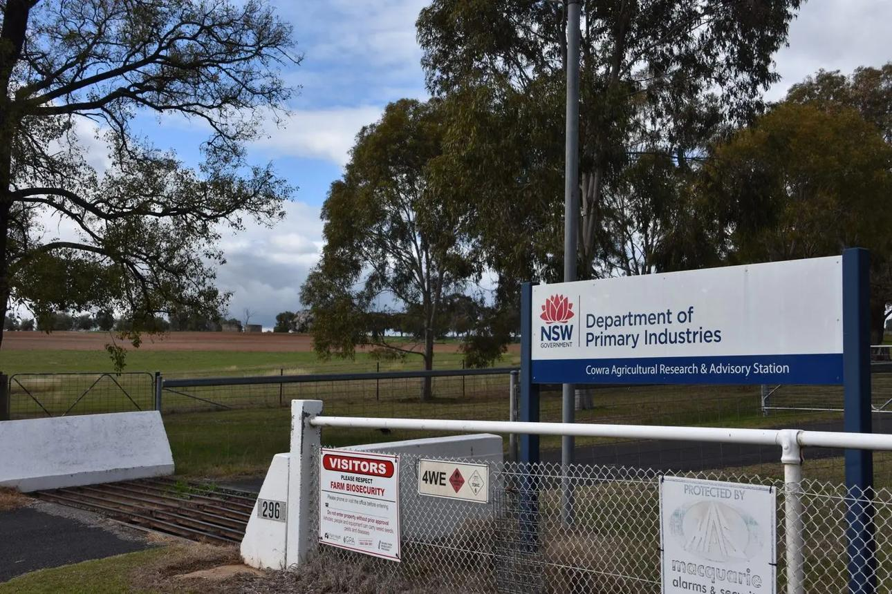
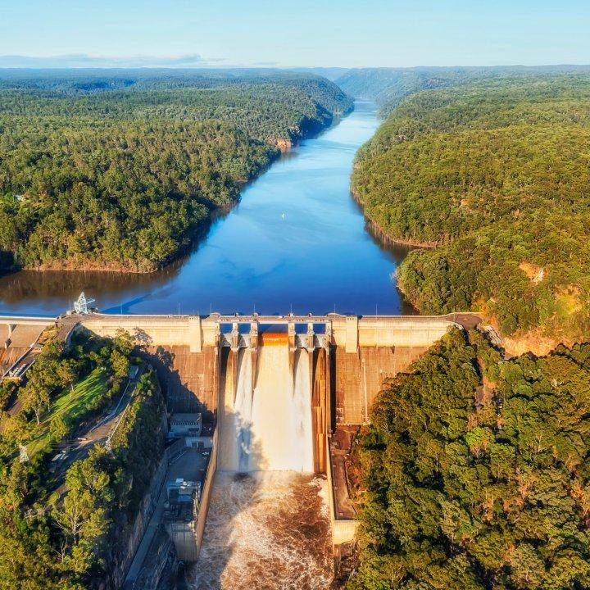
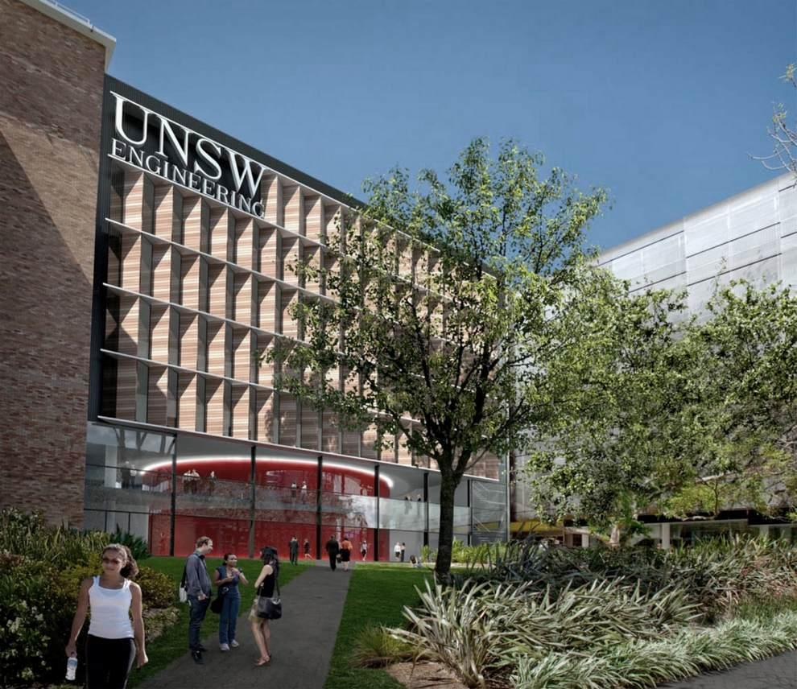
7
I think this is where the architecture becomes a state-scale commercialization platform.
Stakeholder | QAI Opportunity
NSW DPI | Precision agriculture, greenhouse pilots, digital farming.
WaterNSW | Water Digital Twin, desalination optimization, reservoirs.
CSIRO | Nano sensing, climate modelling, sustainability benchmarks.
Universities (UNSW, USYD, Charles Sturt, UTS) | Validation, pilot research, grants, publications.
Local Councils | Water harvesting, smart parks, urban farming.
Farmers / Greenhouses | End-to-end CPS deployment.
This aligns nicely with the commercialization package we already prepared.
10. QAI Valley Vision — Version 3.0 (Strategic Direction)
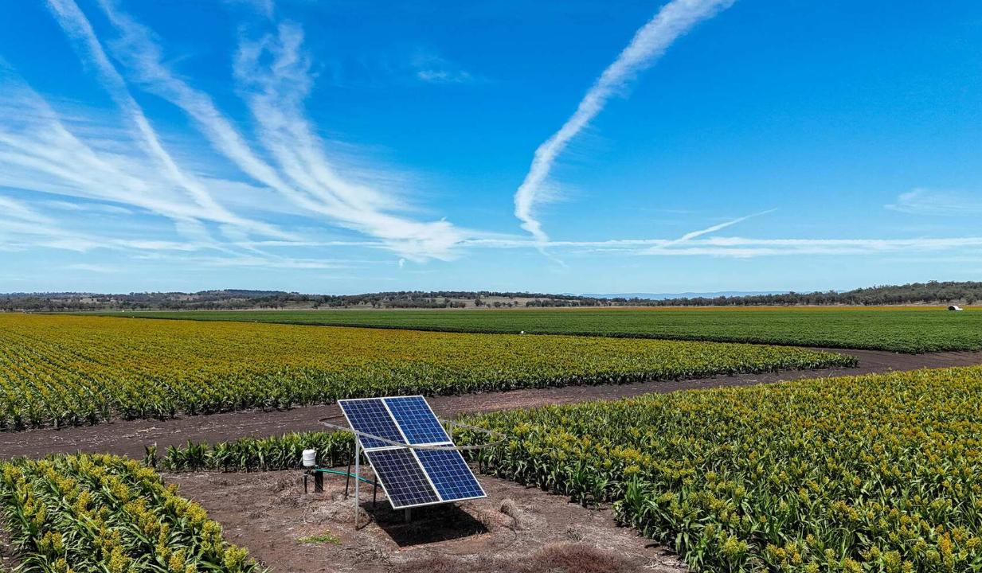
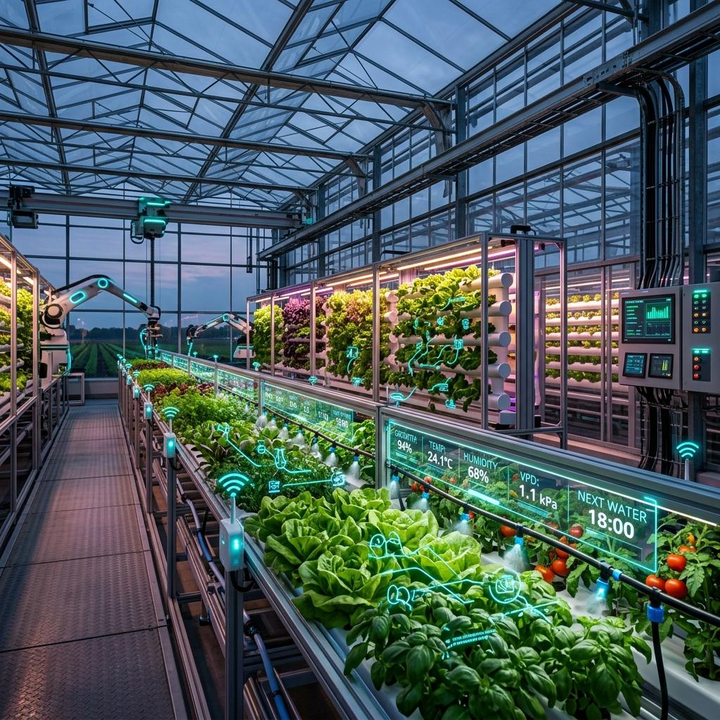
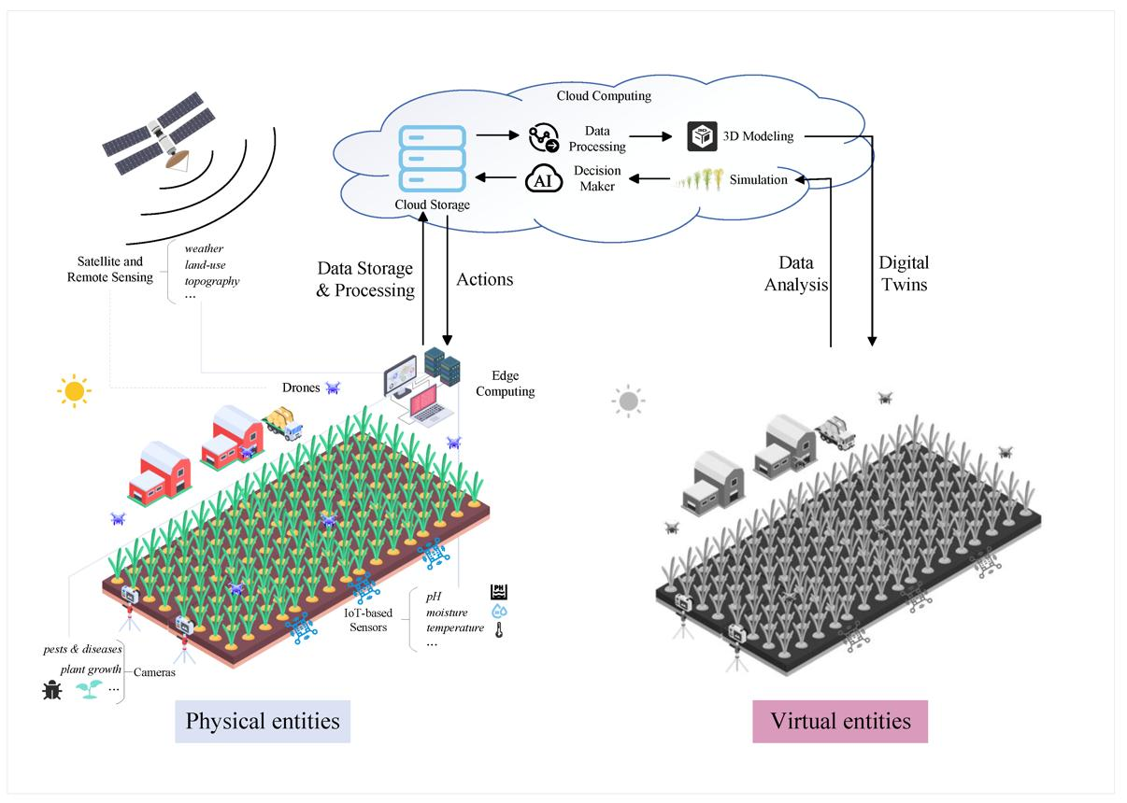
7
I think we now have three concentric commercialization layers.
Layer | Purpose
Layer 1 — QAI CPS Pilot | Azure + Edge + Digital Twin + Sensors + Irrigation + Security. This is the deliverable pilot for NSW farmers.
Layer 2 — Advanced Sustainability Add-ons | Greenhouse Fabric, Water Security Fabric, Nano Sensors, Climate Fabric, Carbon Fabric, Desalination Fabric. Optional commercial modules.
Layer 3 — QAI Valley Platform | Agriculture + Water + Energy + Robotics + Manufacturing + Quantum Datacenter + Academy.
This is exactly the progression we've been building over the past several months.
My recommendation for FAEP / HoldCo Factory
I would treat today's discussion as the beginning of Version 3.0 of the Agriculture Architecture.
Deliverables for tomorrow's VS Code update
We should create five new architecture documents inside enterprise_library/architecture_models/digital_engineering:
- QAI_GREEN_AGRICULTURE_FABRIC_v1.md
- QAI_WATER_SECURITY_FABRIC_v1.md
- QAI_GREENHOUSE_OPTIMIZATION_FABRIC_v1.md
- QAI_CLIMATE_RESILIENCE_FABRIC_v1.md
- QAI_SUSTAINABILITY_AND_CARBON_DIGITAL_TWIN_v1.md
And one new workbook:
QAI_CPS_Optional_Edge_Green_Agri_Addons_Catalogue_v1.xlsx
with approximately 120–150 optional inventory rows grouped into Green Nanotechnology, Water Security, Greenhouse, Climate, Sustainability, Robotics/UAV, and Edge Add-ons.
Why I like this direction
This is no longer just a smart-farm pilot. It evolves into a National QAI Sustainability Platform that can support NSW initiatives around:
- Water resilience and desalination.
- Climate adaptation and drought resilience.
- Greenhouse modernization.
- Carbon neutrality and biodiversity.
- Precision agriculture and food security.
- Digital engineering and quantum-ready infrastructure.
It also fits exceptionally well with your long-term QAI Valley & City vision, where agriculture becomes one vertical domain sharing the same Digital Thread, Digital Twin, QAI Control Plane, Edge Runtime, and future Quantum Runtime across many industries.
I think this is one of the strongest architectural expansions we've developed so far, and it deserves its own Version 3.0 architecture package in the HoldCo Factory repository.
// RESPONSE 2
Good morning, Vijay. This is an excellent next step, and I think it takes the QAI CPS Pilot from Precision Agriculture v1 toward a National AgriTech Platform v2 for Australia (NSW first, then Canada and New Zealand).
I would not mix these capabilities into the core pilot BOM. Instead, they become a new optional workbook and architecture package that sits above the CPS Pilot. This is similar to how Azure, Intel, and Edge add-ons are optional infrastructure, while these become Domain Innovation Add-ons.
QAI AgriTech Innovation Catalogue v1.0 (NSW / Australia)
QAI AgriTech Innovation Catalogue v1.0
NSW Pilot
Canada Ready
New Zealand Ready
QAI Valley Program
This becomes a new commercial workbook and architecture extension for the HoldCo Factory / FAEP / QAI Valley ecosystem.
The goal is to help governments, councils, research centers, water authorities, greenhouse operators, vineyards, orchards, and large farms adopt advanced technologies progressively.
Master Architecture — QAI Sustainable Agriculture Platform
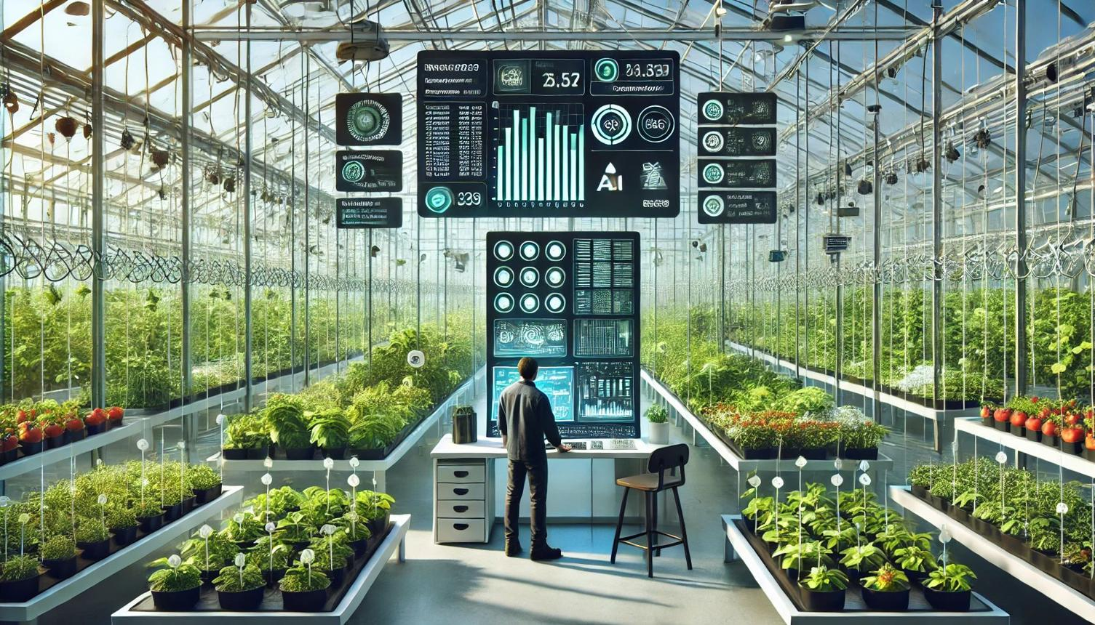
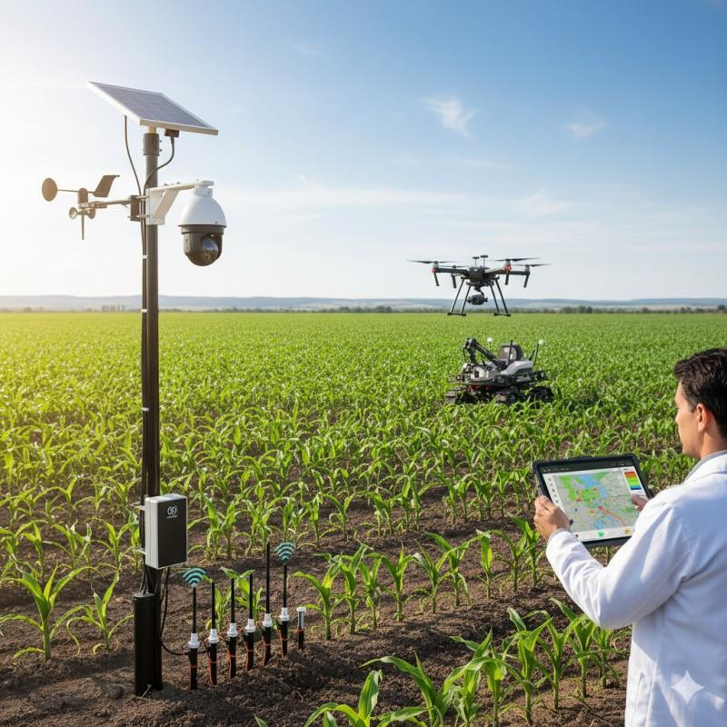
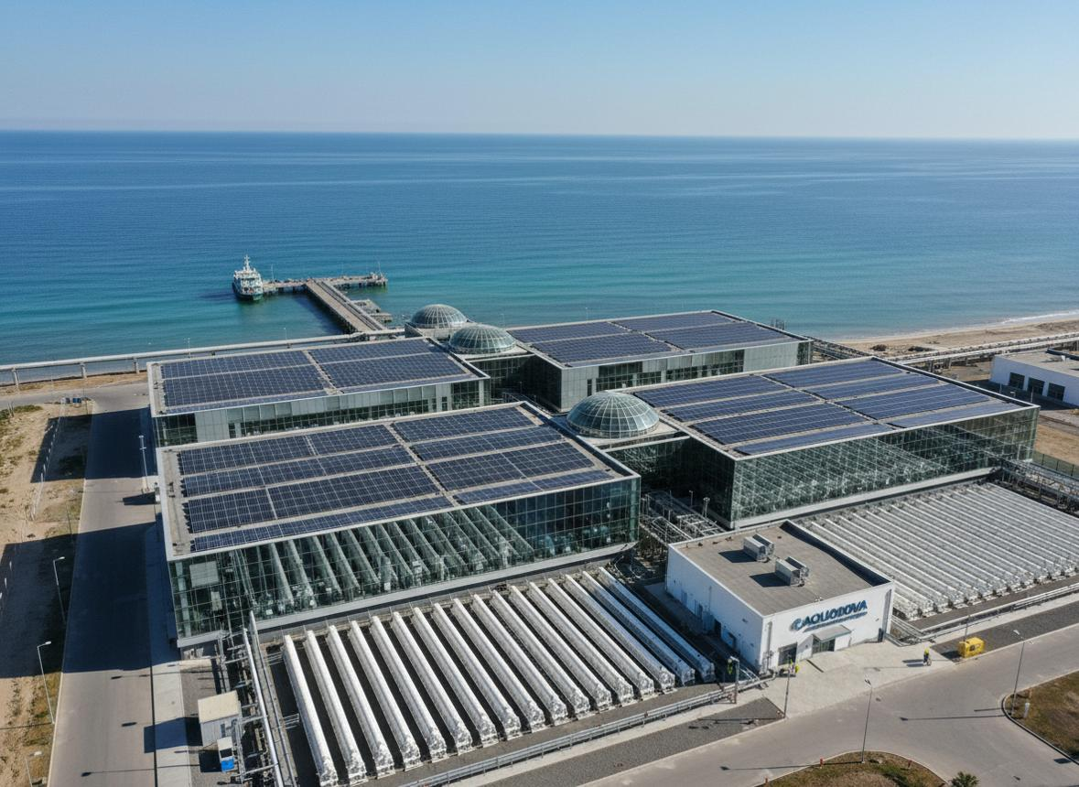
7
This extends the CPS architecture into six sustainability domains.

This becomes Version 2 of the architecture.
Domain 1 — Water Security Fabric (Highest Priority for NSW)
NSW Priority
Australia's largest long-term challenge is water.
Water Fabric Components
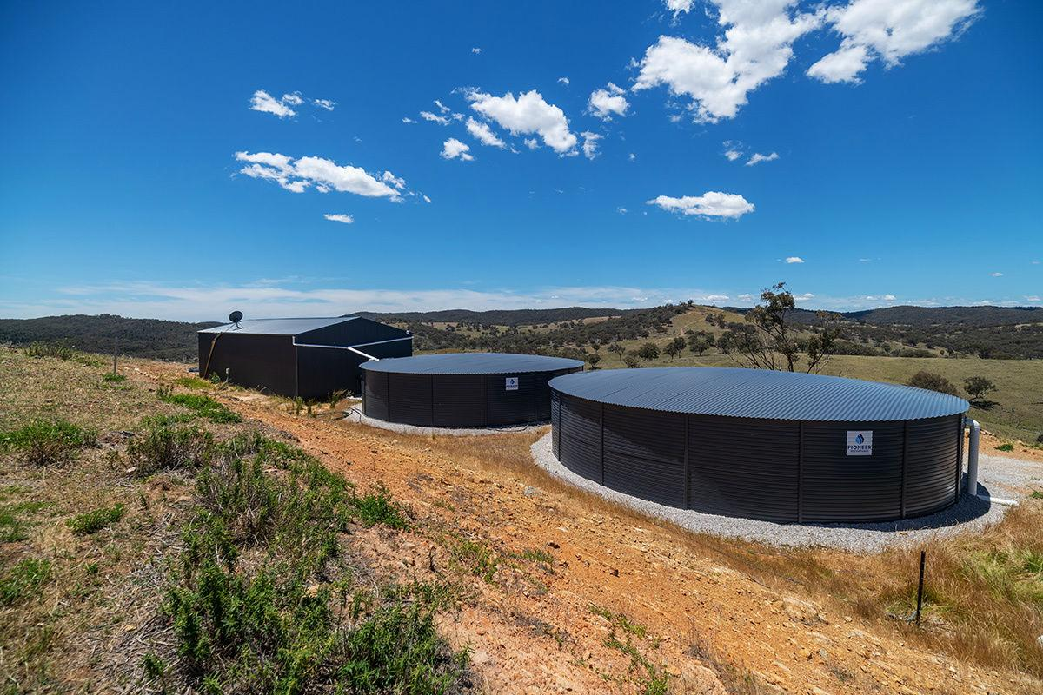

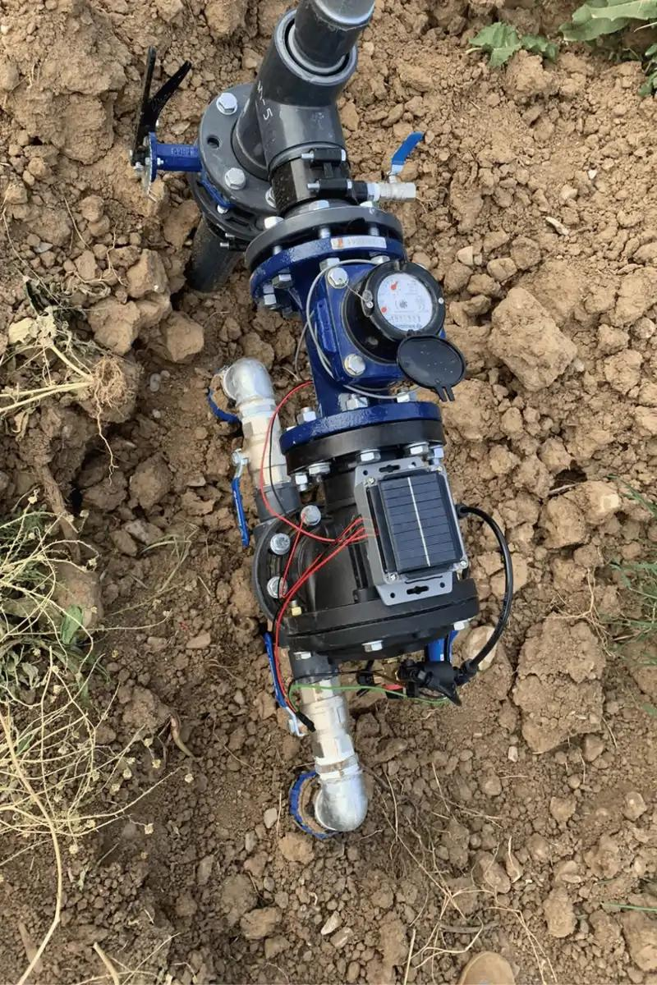
6
Logical Component | Purpose | Pilot
Rain Water Harvesting Manager | Capture rainfall, storage prediction, tank optimization. | PILOT
Water Quality Sensor Fabric | pH, EC, salinity, turbidity, nitrate monitoring. | PILOT
Desalination Optimization Fabric | Optimize solar-powered desalination scheduling. | OPTIONAL
Groundwater Prediction Fabric | AI + Digital Twin groundwater estimation. | OPTIONAL
Water Leakage Detection Fabric | Pipeline and irrigation leakage detection. | PILOT
Water Allocation Optimizer | QAOA / optimization scheduling. | OPTIONAL
Water Digital Twin
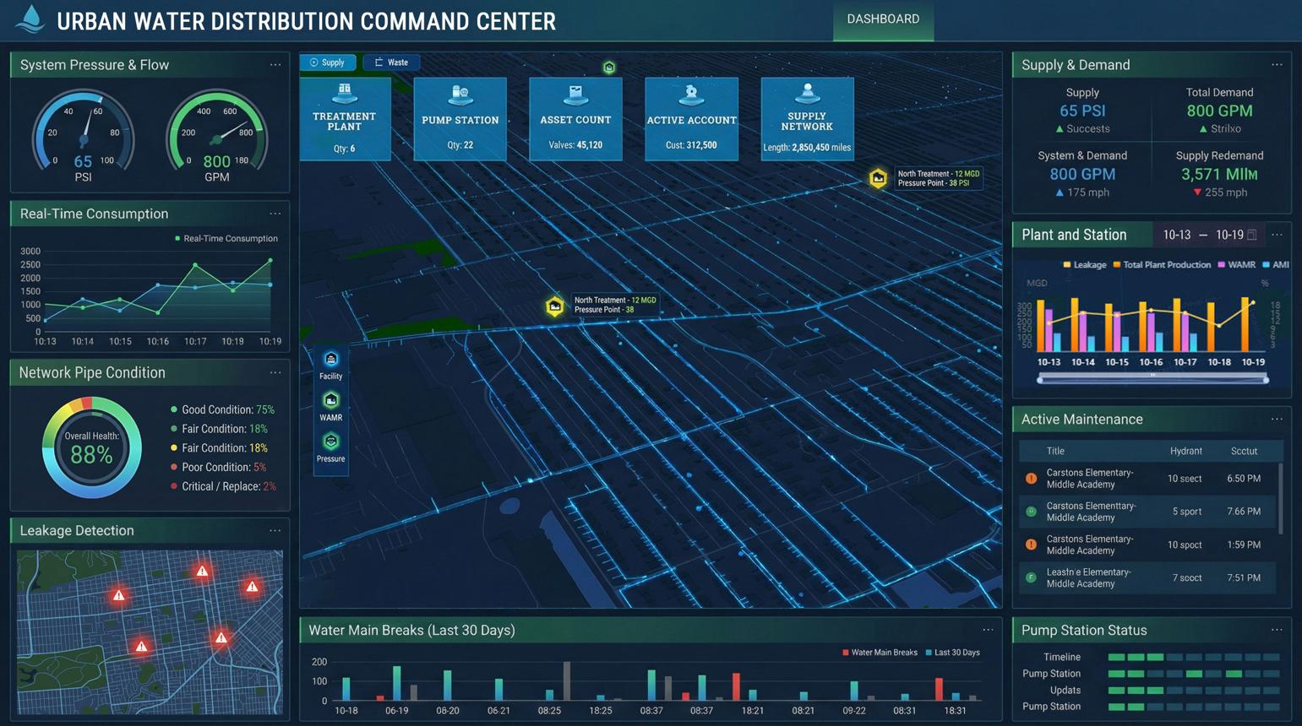
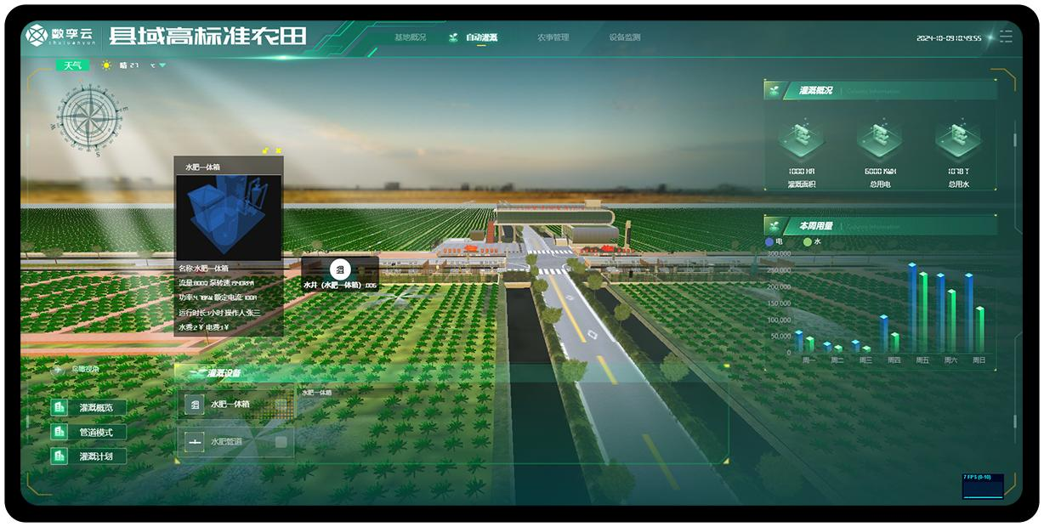
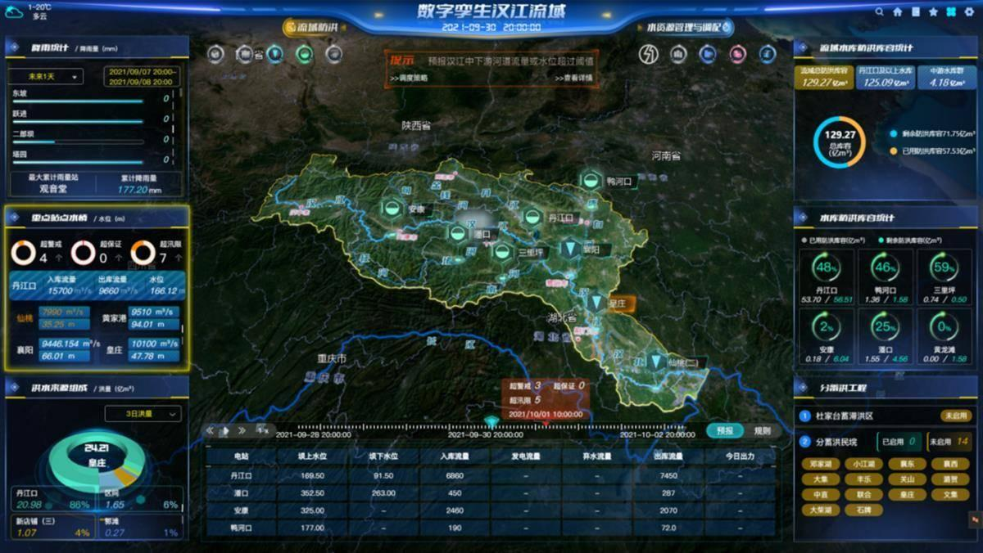
7
Digital Twin tracks:
- River
- Reservoir
- Tank
- Groundwater
- Irrigation network
- Pumps
- Valves
- Consumption
- Forecast rainfall.
Water QAI Optimization
QAI Fabric | Benefit
Graph Fabric | Optimize irrigation network graph.
Adaptive Fabric | Allocate water across farm zones.
Resource Fabric | Reduce pumping energy.
Quantum Optimization Fabric | Optimize irrigation schedule.
Digital Twin Fabric | Predict water demand 24–72 hours ahead.
Domain 2 — Green Nanotechnology Fabric
Research Add-on
Green Nano Sensors
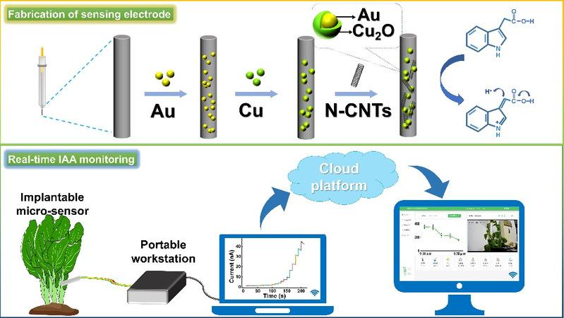
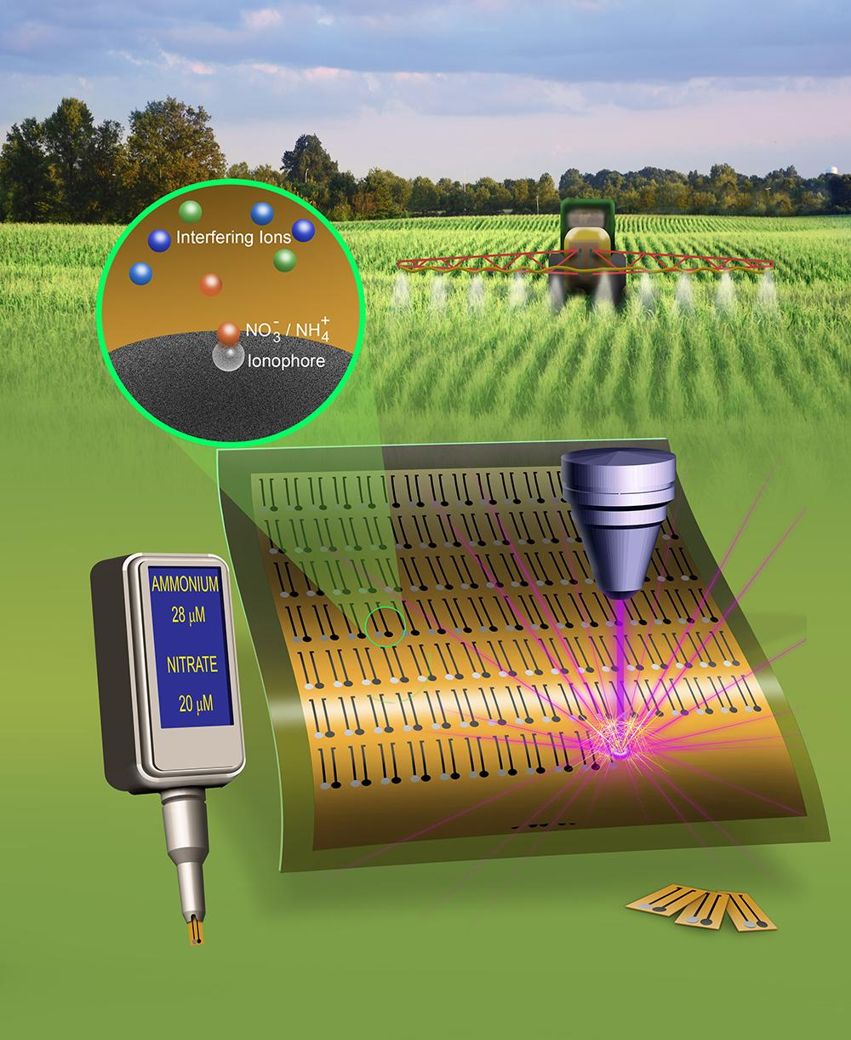
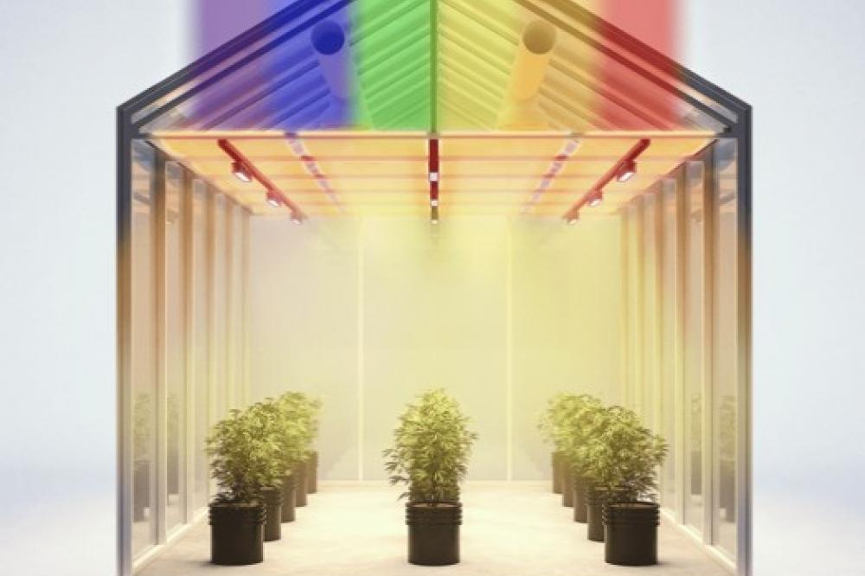
7
These become optional sensor technologies.
Nano Sensor | Agriculture Application
Carbon Nanotube Sensor | Soil nutrient detection.
Graphene Sensor | Humidity and VOC sensing.
Carbon Quantum Dots | Water contamination sensing.
Metal Oxide Nano Sensors | Greenhouse gas detection.
Nano Optical Sensor | Plant disease detection.
QAI Nano Fabric
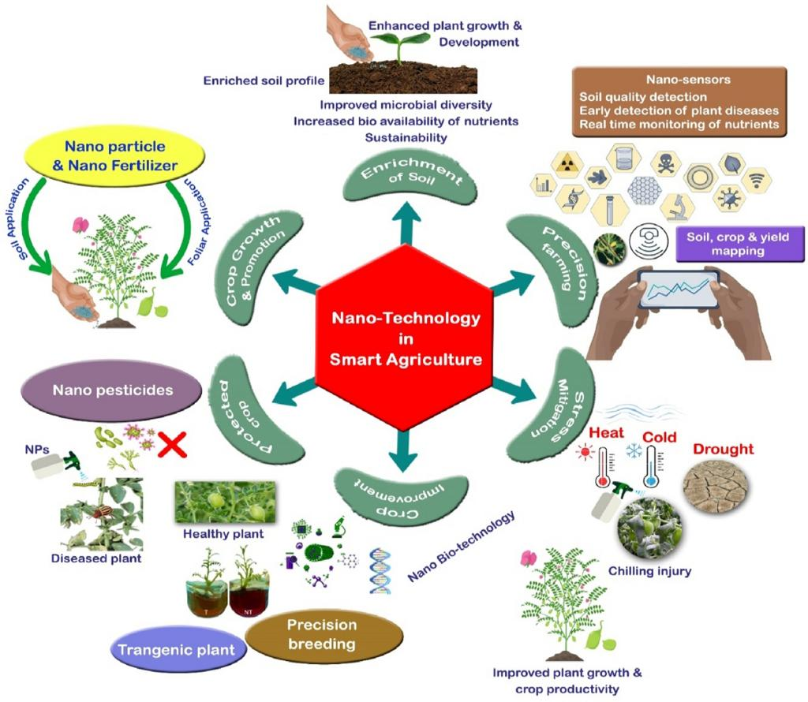

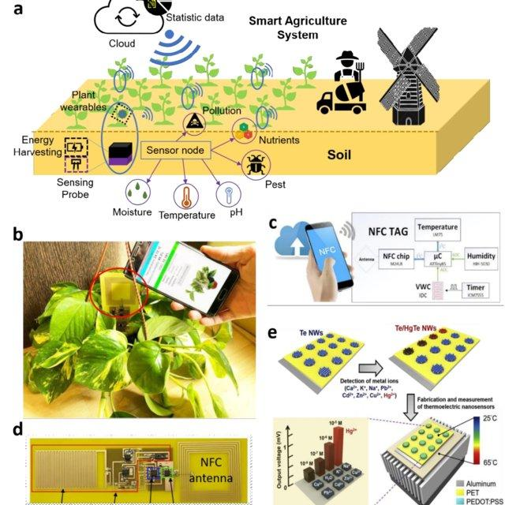
7
Pipeline:
Nano Sensor
↓
Edge Gateway
↓
AI Feature Extraction
↓
QAI Fabric
↓
Digital Twin
↓
Farmer Recommendation
Quantum + Nano Opportunities
Research Theme | QAI Opportunity
Quantum Machine Learning | Analyze nano sensor signals.
Quantum Feature Mapping | Detect weak plant stress signatures.
Quantum Optimization | Optimize nano sensor placement.
Quantum Simulation | Model nano material interactions.
These remain research modules.
Domain 3 — Greenhouse Intelligence Fabric
Major Pilot Extension
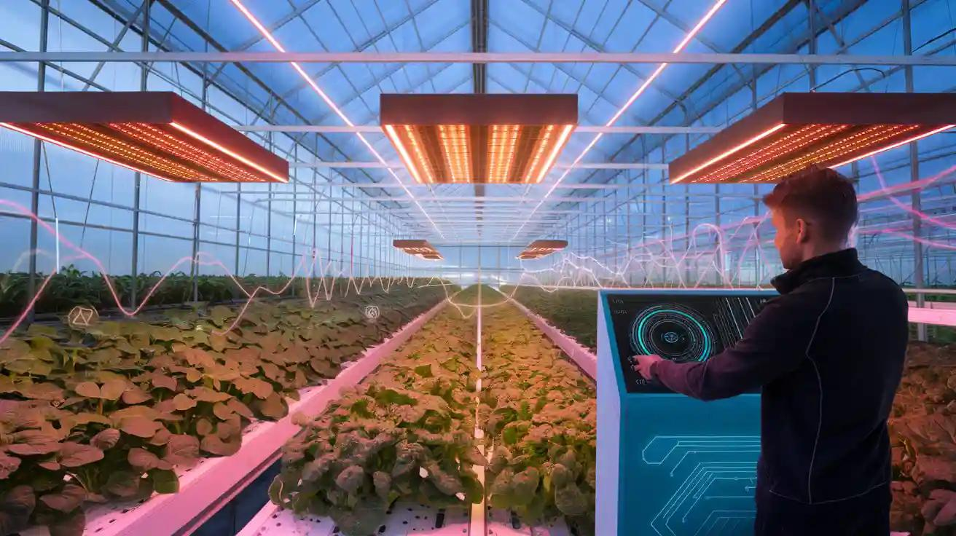
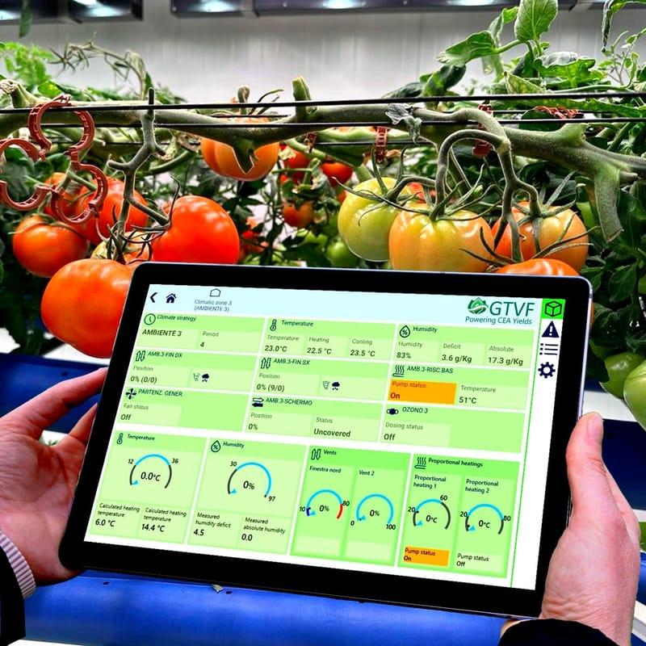
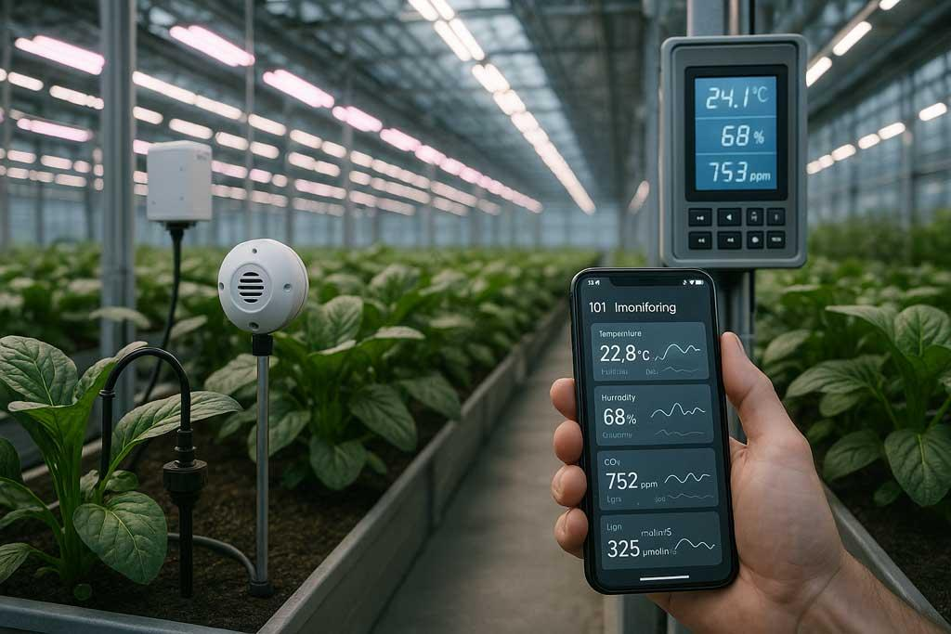
7
Greenhouse Layers

Greenhouse Innovation Inventory
Component | Function | Status
Quantum Dot Roof Film | Convert UV to PAR light. | OPTIONAL
LED Adaptive Lighting Fabric | Growth-stage lighting optimization. | OPTIONAL
VOC Nano Sensor Fabric | Early disease detection. | OPTIONAL
Climate Prediction Fabric | Humidity/temperature prediction. | PILOT Candidate
HVAC Optimization Fabric | Optimize ventilation/heating. | OPTIONAL
Pollination Monitoring Fabric | Bee activity/flower analysis. | FUTURE
Domain 4 — Climate Resilience Fabric
NSW Water + Climate Mission
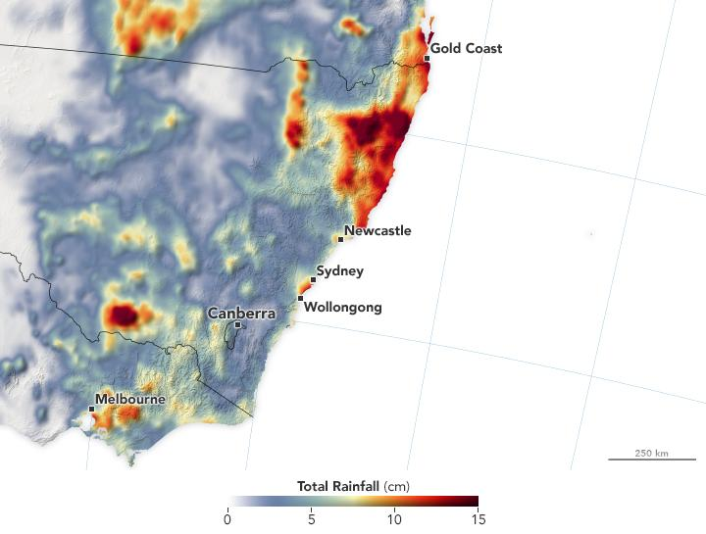
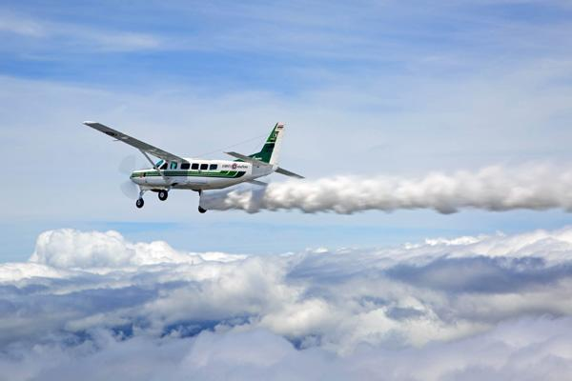
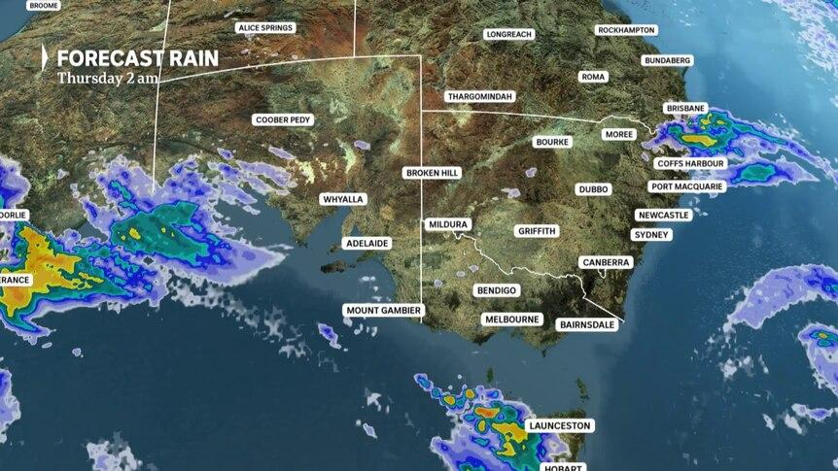
8
Climate Fabric Components
Component | Purpose
Weather Fabric | Integrate BOM weather, satellite data, local stations.
Cloud Seeding Decision Fabric | Research simulation for rainfall enhancement.
Rainfall Prediction Fabric | AI + Digital Twin rainfall forecasting.
Drought Risk Fabric | Long-term drought prediction.
Flood Prediction Fabric | River overflow simulation.
Microclimate Fabric | Farm-specific weather prediction.
Cloud Seeding (Research Module)
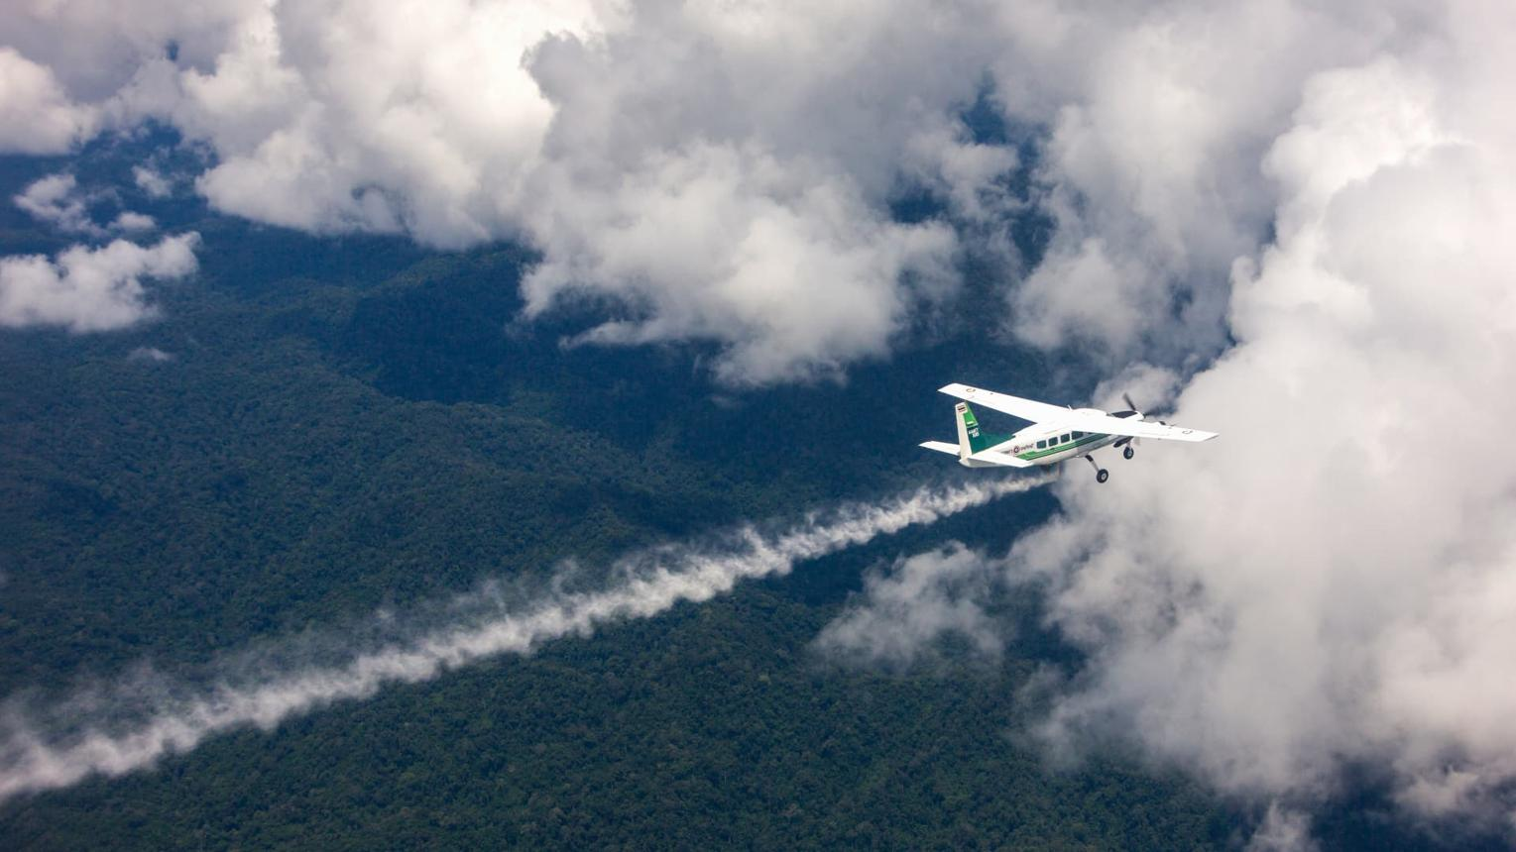
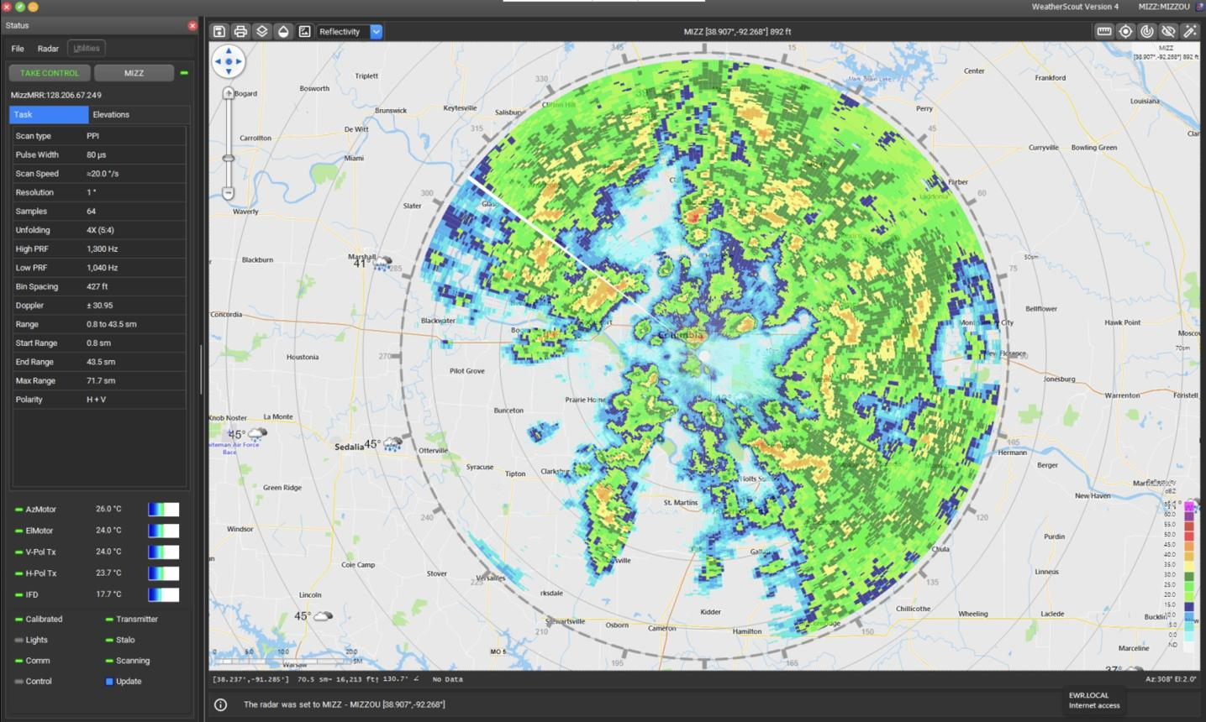
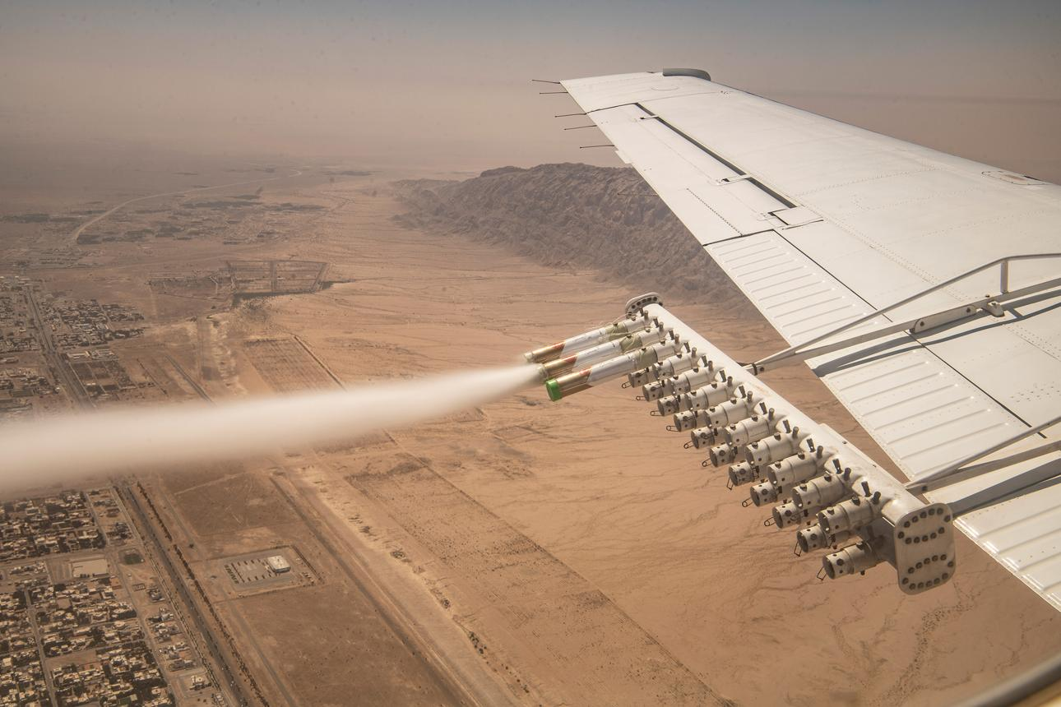
5
Important classification
Research-only module
Cloud seeding stays outside the pilot.
We model it in the Digital Twin and decision-support workflow, but we do not implement operational cloud seeding in the pilot deployment.
Domain 5 — Carbon & Sustainability Fabric
Government & ESG Ready
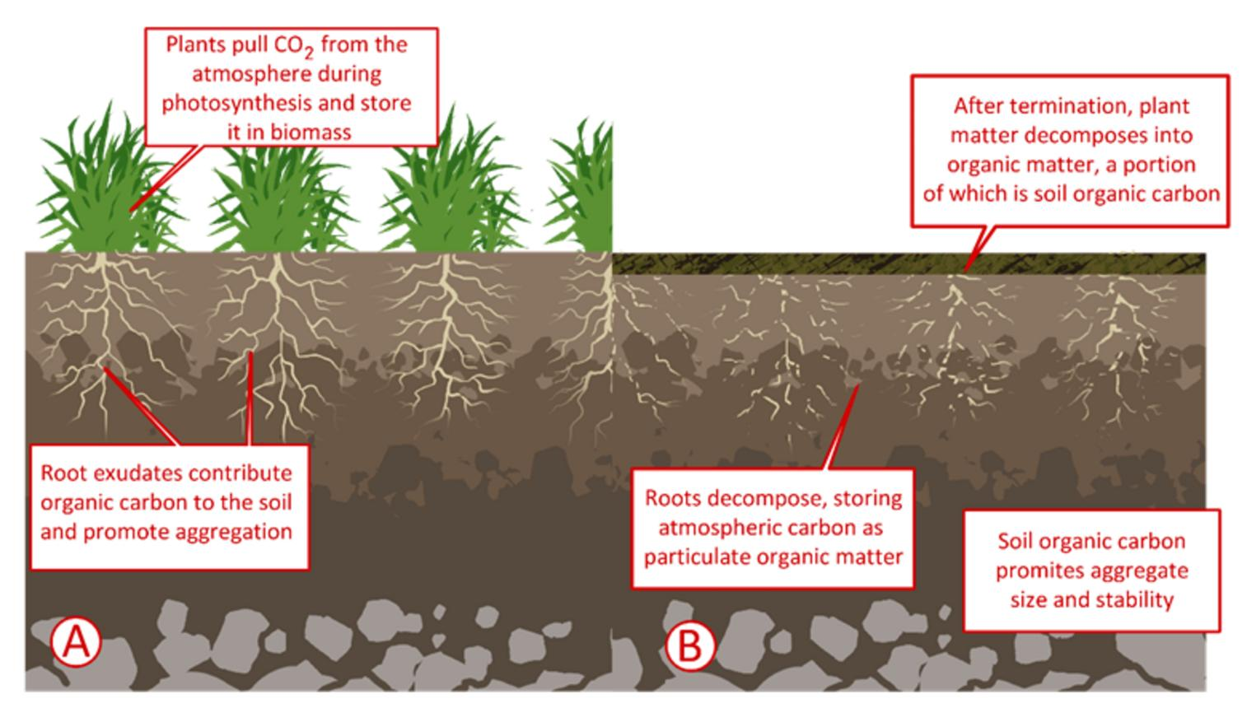
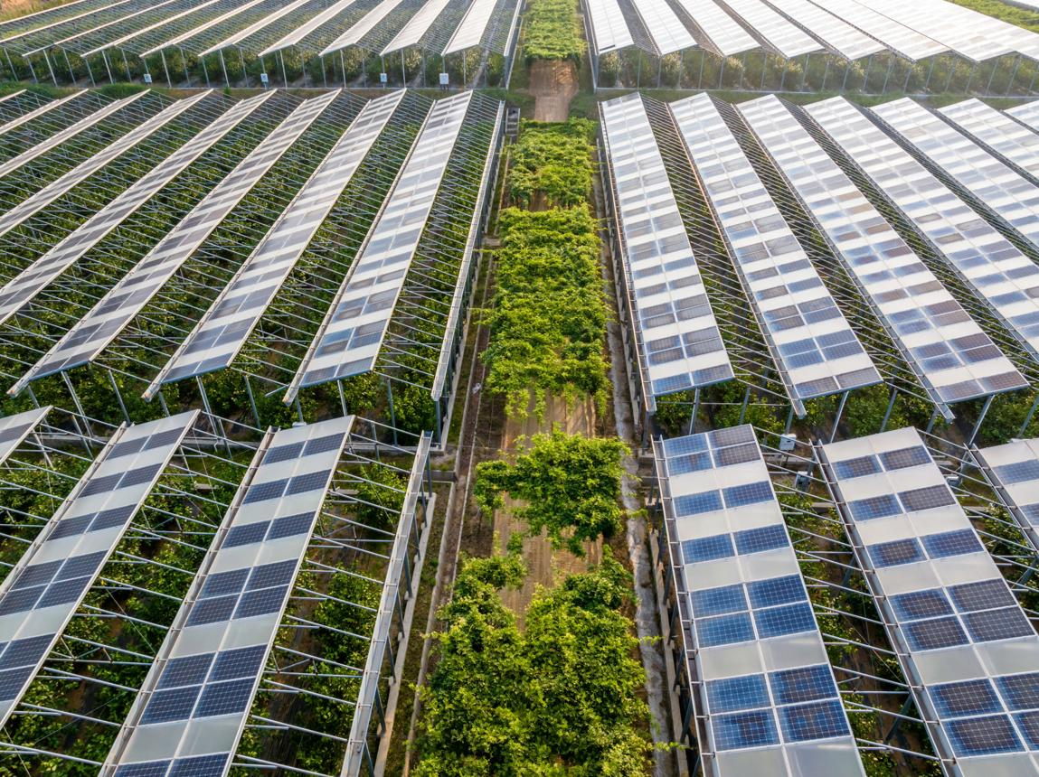
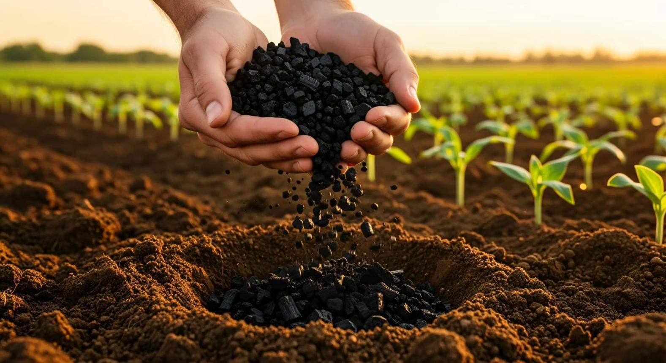
6
Carbon Fabric Components
Component | Purpose
Carbon Sequestration Twin | Estimate soil carbon.
Carbon Credit Fabric | Estimate carbon credit potential.
Solar Optimization Fabric | Optimize renewable generation.
Energy Storage Fabric | Battery scheduling.
Emission Monitoring Fabric | CO₂ / methane monitoring.
Water-Energy Fabric | Optimize water-energy balance.
Carbon Digital Twin
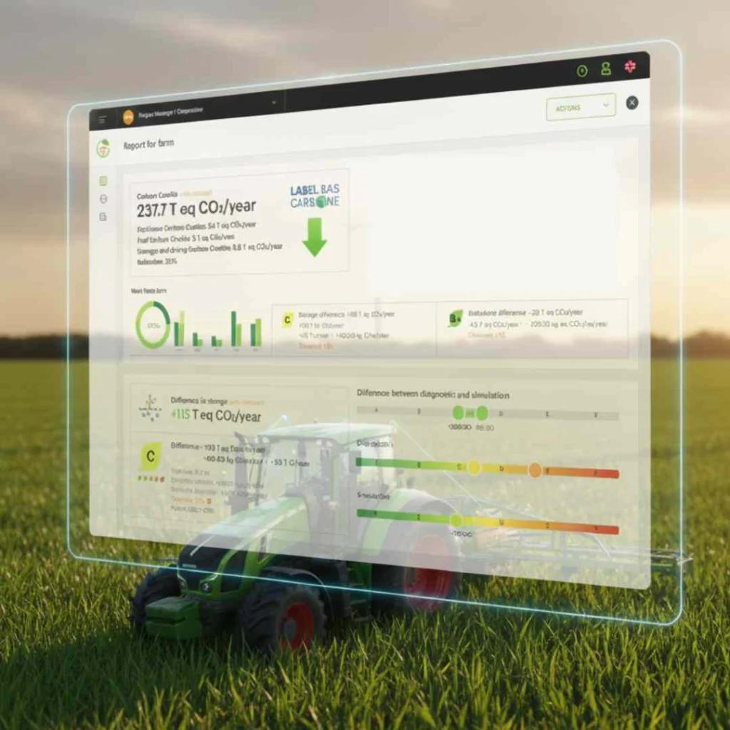
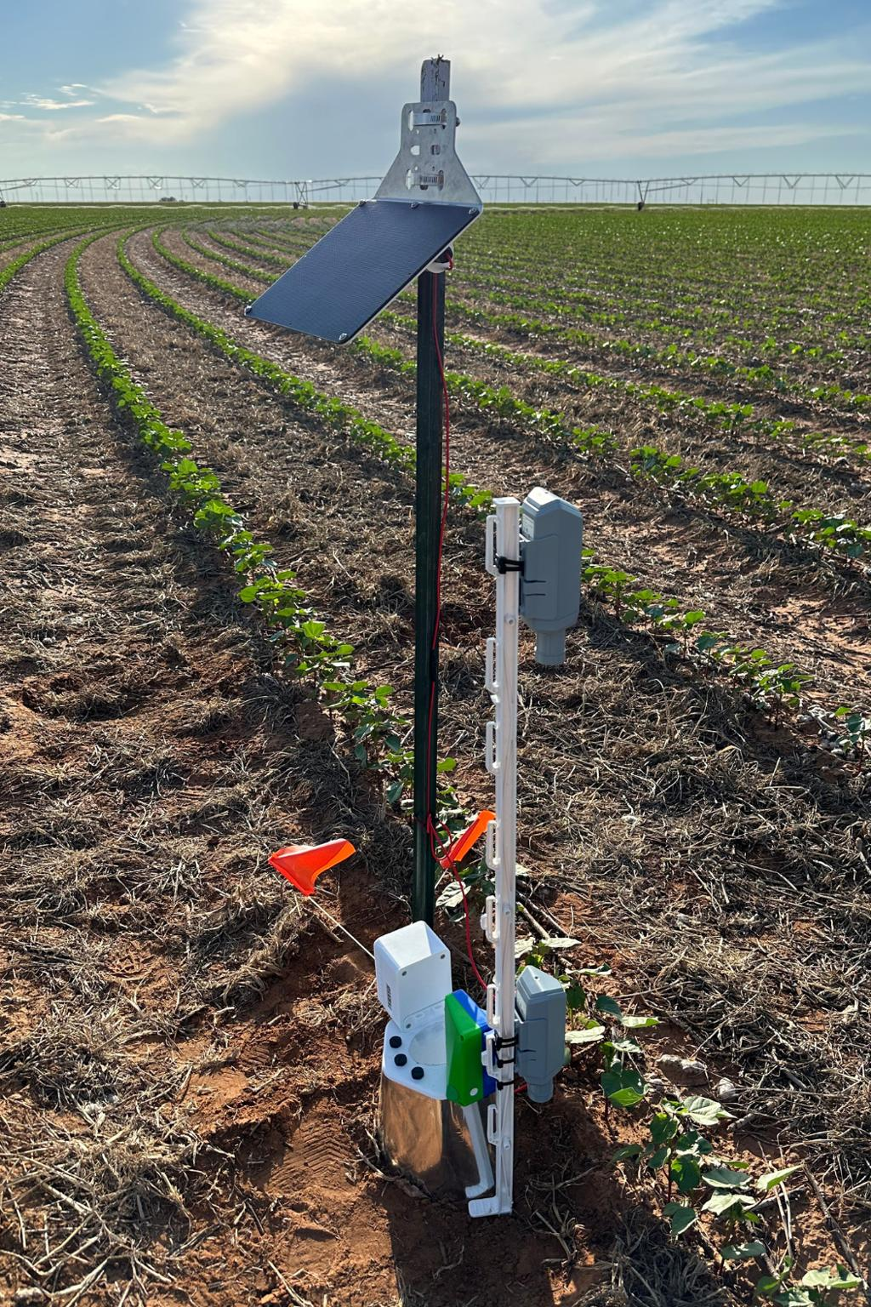
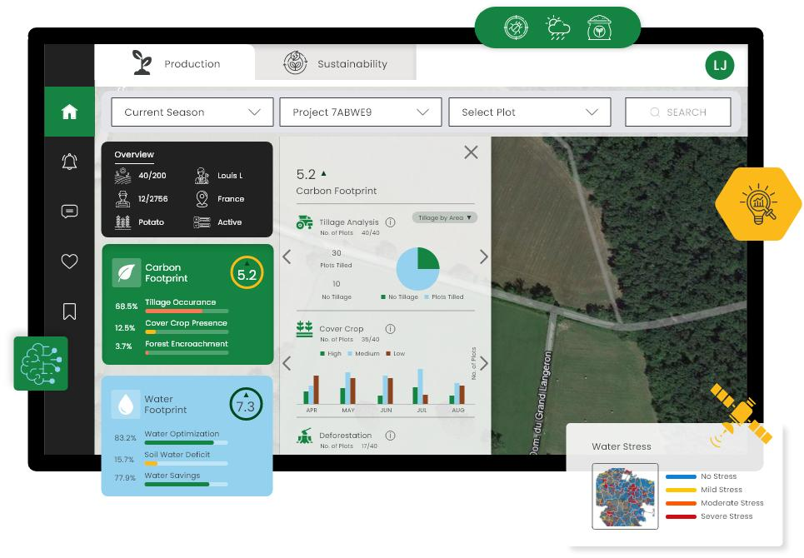
7
Useful for:
- NSW sustainability grants.
- Carbon farming programs.
- ESG reporting.
- Renewable agriculture.
Domain 6 — Water Desalination Innovation Fabric
Future NSW Innovation
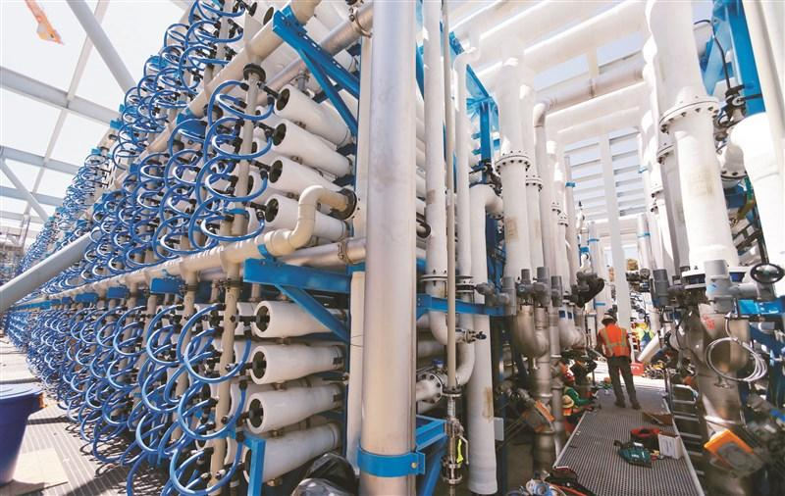
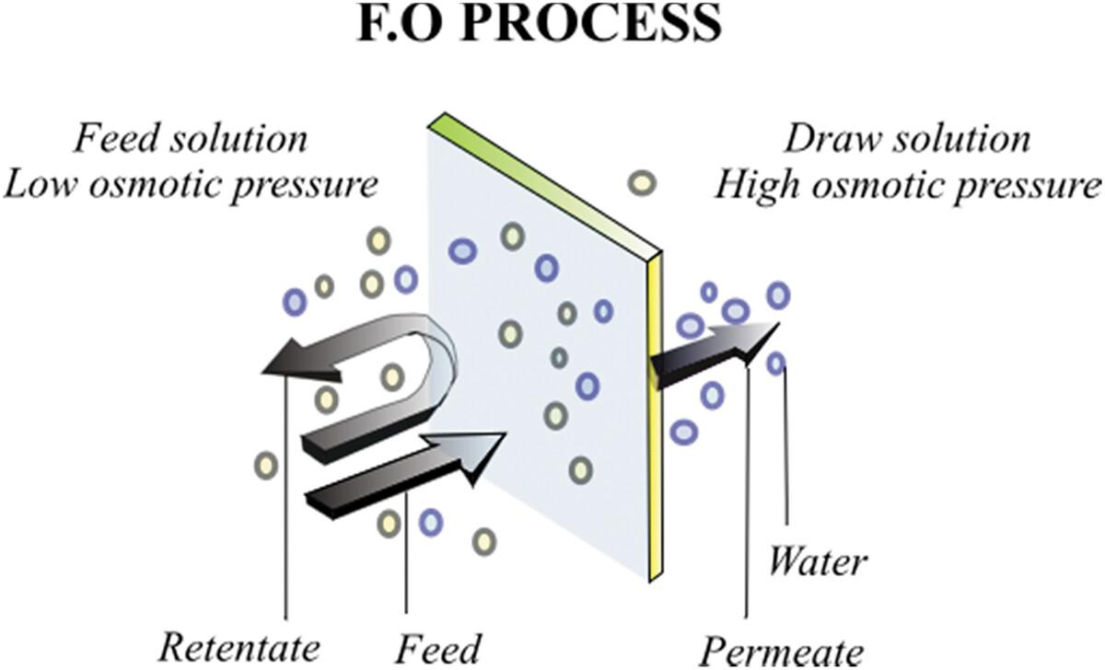
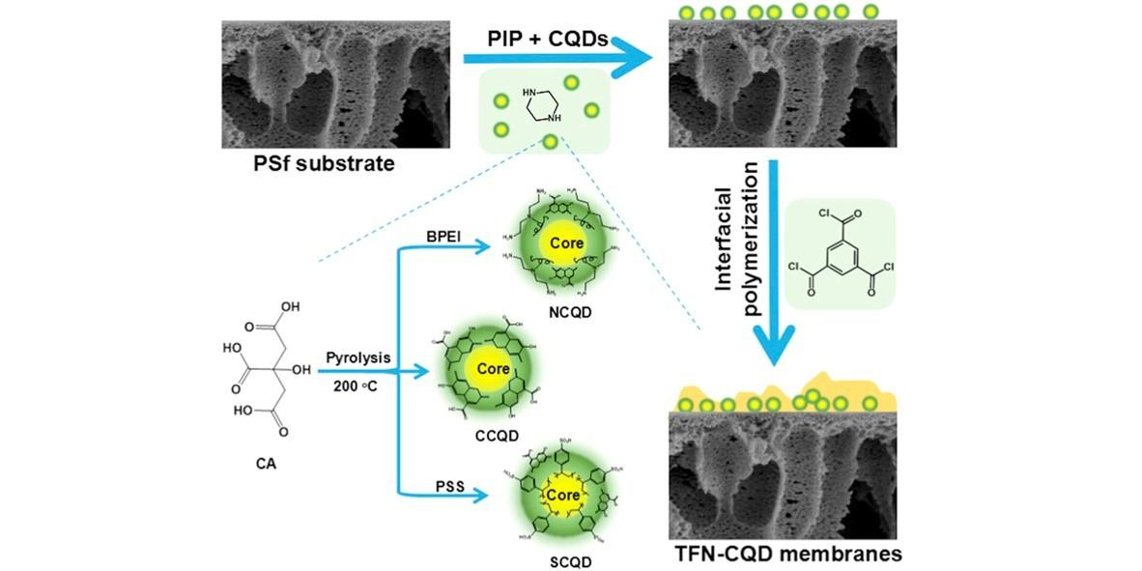
7
Desalination Fabric
Component | Purpose | Status
Solar Desalination Scheduler | Optimize renewable desalination. | OPTIONAL
Forward Osmosis Fabric | Water production optimization. | RESEARCH
Carbon Quantum Dot Membrane Twin | Membrane performance monitoring. | RESEARCH
Brine Optimization Fabric | Waste reduction simulation. | RESEARCH
Water Storage Digital Twin | Reservoir optimization. | OPTIONAL
Quantum + Nano Greenhouse Architecture
This is one of the exciting research extensions.
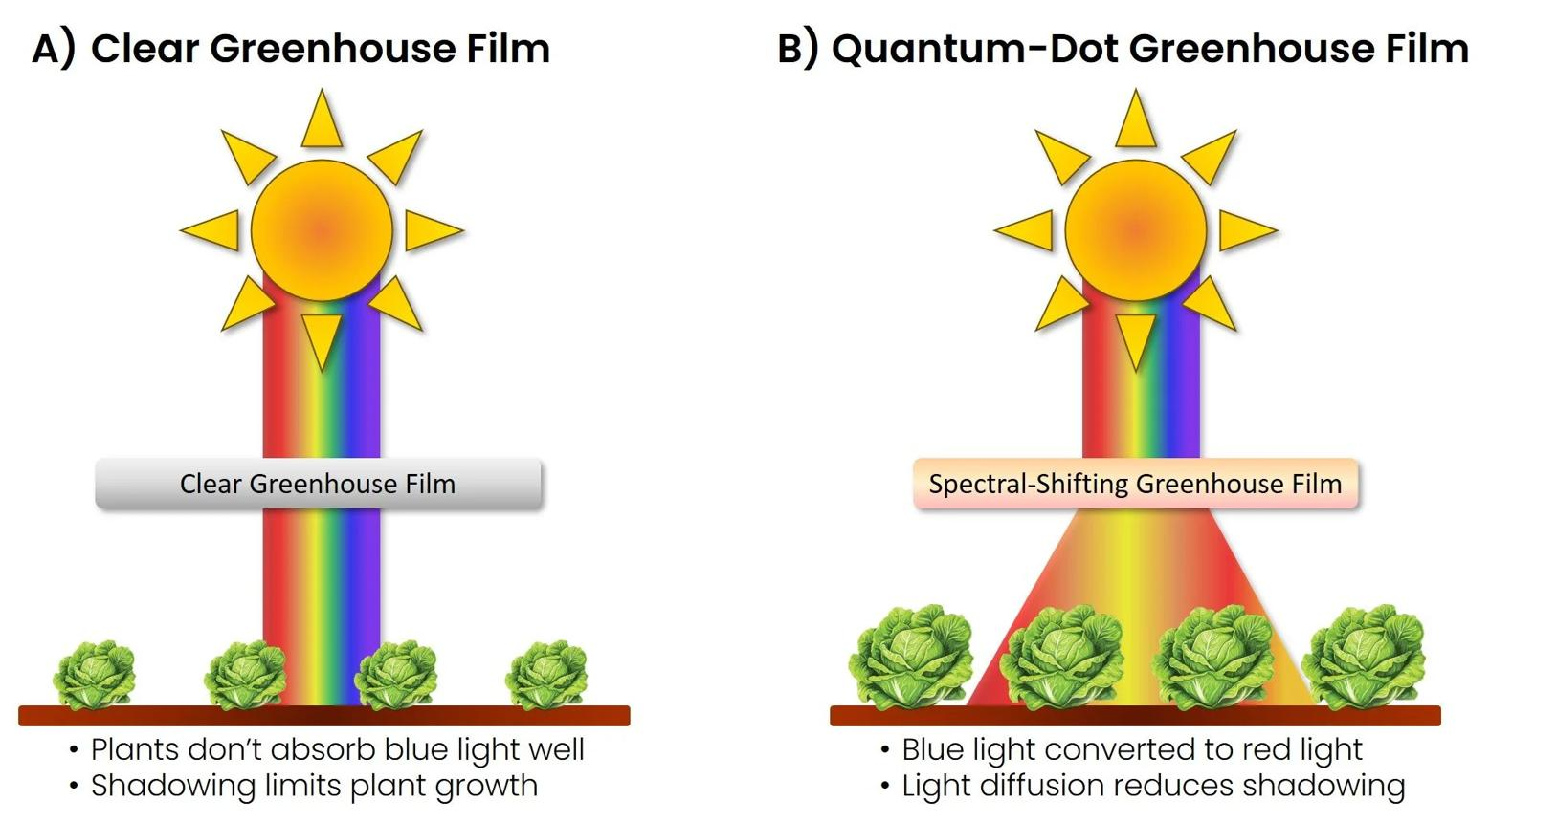
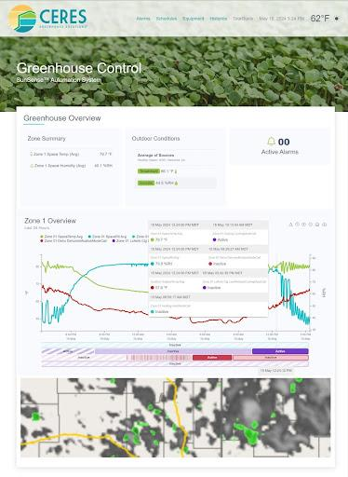
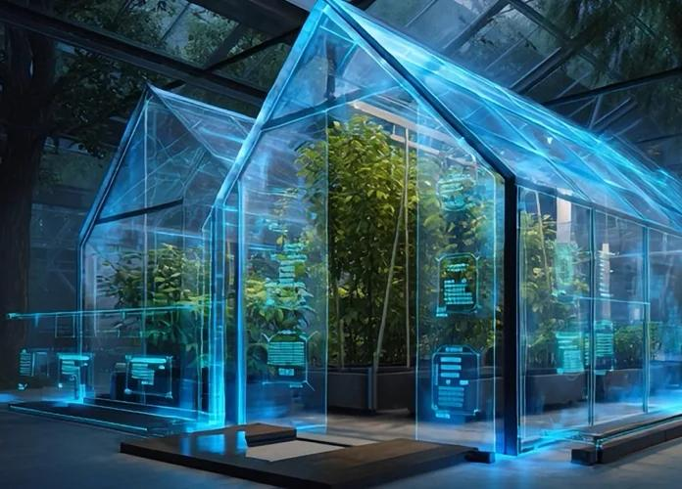
6

New Optional Fabric Inventory (About 35–40 Rows)
Water Fabric
ID | Component | Status
WATER-001 | Rainwater Harvesting Fabric | PILOT
WATER-002 | Smart Water Storage Twin | PILOT
WATER-003 | Leakage Detection Fabric | PILOT
WATER-004 | Groundwater Prediction Fabric | OPTIONAL
WATER-005 | Desalination Scheduler | RESEARCH
WATER-006 | Forward Osmosis Twin | RESEARCH
Nano Fabric
ID | Component | Status
NANO-001 | Carbon Nanotube Soil Sensor | OPTIONAL
NANO-002 | Graphene Gas Sensor | OPTIONAL
NANO-003 | Carbon Quantum Dot Water Sensor | RESEARCH
NANO-004 | Nano Optical Disease Sensor | OPTIONAL
NANO-005 | Quantum Dot Greenhouse Film | RESEARCH
Climate Fabric
ID | Component | Status
CLIMATE-001 | Microclimate Prediction Fabric | PILOT Candidate
CLIMATE-002 | Drought Risk Fabric | OPTIONAL
CLIMATE-003 | Flood Prediction Fabric | OPTIONAL
CLIMATE-004 | Cloud Seeding Simulation Fabric | RESEARCH
CLIMATE-005 | Weather Digital Twin | PILOT Candidate
Greenhouse Fabric
ID | Component | Status
GH-001 | LED Light Optimization Fabric | OPTIONAL
GH-002 | HVAC Optimization Fabric | OPTIONAL
GH-003 | VOC Plant Stress Fabric | OPTIONAL
GH-004 | Pollination Monitoring Fabric | FUTURE
GH-005 | Quantum Dot Roof Manager | RESEARCH
Sustainability Fabric
ID | Component | Status
CARBON-001 | Carbon Twin | OPTIONAL
CARBON-002 | Carbon Credit Fabric | OPTIONAL
CARBON-003 | Renewable Energy Fabric | OPTIONAL
CARBON-004 | Water-Energy Optimizer | OPTIONAL
CARBON-005 | Emission Monitoring Fabric | OPTIONAL
NSW Government / Research Mapping Sheet
This is useful commercially.
NSW Focus Area | QAI Fabric | Potential Partner Category
Water scarcity | Water Security Fabric | Water authorities, DPI, councils
Greenhouse modernization | Greenhouse Fabric | Universities, horticulture centers
Drought resilience | Climate Fabric | Climate agencies
Carbon farming | Carbon Fabric | Sustainability programs
Desalination innovation | Water Innovation Fabric | Research organizations
Nano agriculture | Nano Fabric | Nanotechnology research institutes
Digital agriculture | CPS + Digital Twin + Edge Fabric | Microsoft, Intel, IBM, Dell ecosystem
Updated QAI Valley Architecture (Version 3.0)
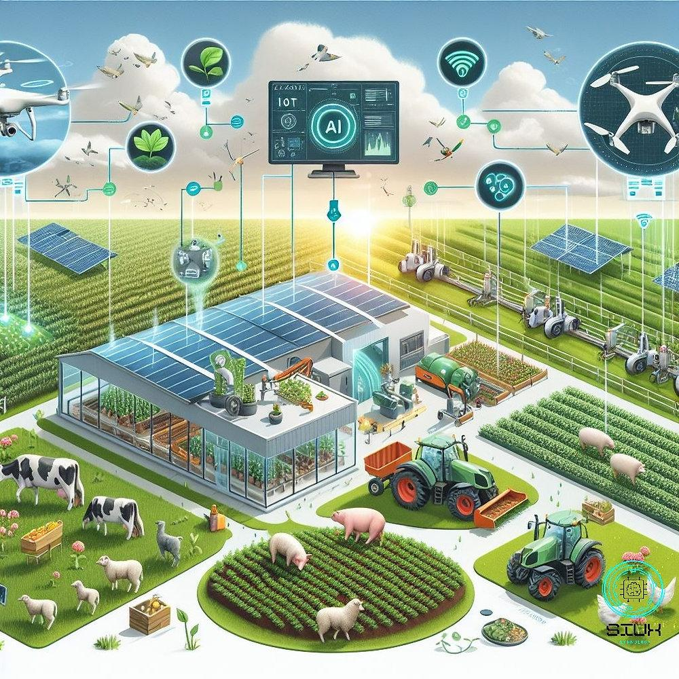

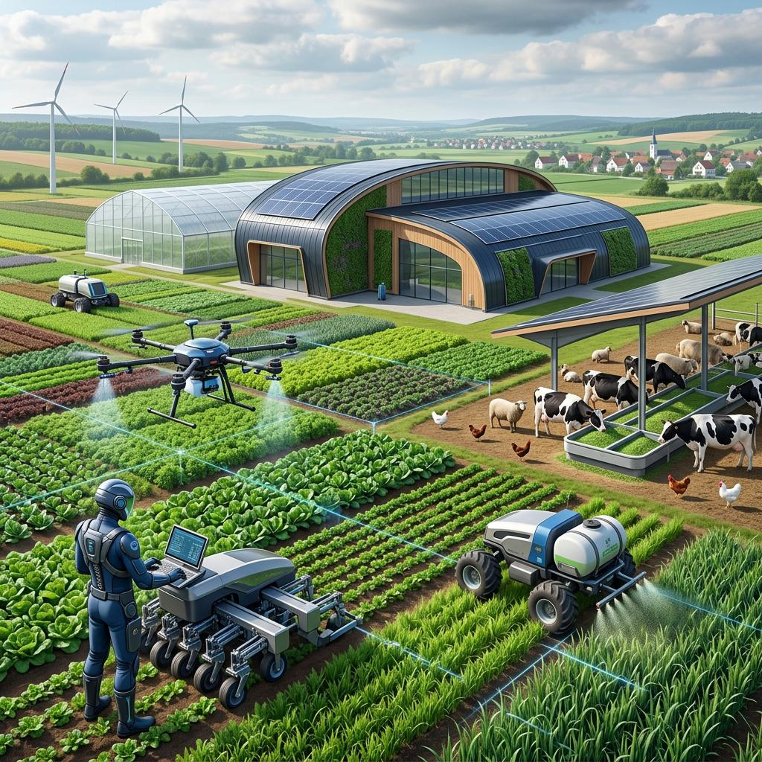
6

Recommendation for the HoldCo VS Code Repository
This fits naturally into the Digital Thread we created yesterday.
New folder inside 00_holdco_factory
enterprise_library
└── architecture_models
└── sustainable_agriculture
├── README.md
├── water_security_fabric.md
├── greenhouse_fabric.md
├── nano_sensor_fabric.md
├── climate_resilience_fabric.md
├── carbon_sustainability_fabric.md
├── desalination_fabric.md
├── qai_greenhouse_reference_architecture.md
├── nsw_agritech_partner_mapping.md
└── inventory
├── optional_addon_inventory.xlsx
├── pilot_addons.xlsx
└── sustainability_metrics.xlsx
This keeps Digital Engineering, Digital Twin, and Sustainable Agriculture as separate architectural domains under the HoldCo Factory Digital Thread.
My recommendation for Version 3.0 of the QAI CPS Pilot
Version 3.0 scope
Keep the pilot small and make the innovation catalogue modular.
Keep in the first NSW pilot
- Water Security Fabric (rainwater harvesting, leakage detection, water quality).
- Greenhouse Climate Fabric (microclimate sensors and Digital Twin).
- Azure IoT Edge + Edge AI Runtime.
- CPS + Digital Twin + QAI Runtime.
Keep as optional innovation modules
- Green nanotechnology sensors.
- Quantum-dot greenhouse films.
- Solar desalination optimization.
- Cloud-seeding simulation.
- Carbon-credit and ESG modules.
- Advanced quantum optimization for greenhouse HVAC and water allocation.
This keeps the commercial pilot affordable and practical, while creating a roadmap of 60–80 optional innovation components that can later become grant-funded research projects with NSW DPI, universities, CSIRO, Engineers Australia, Microsoft, Intel, IBM, Dell, and future QAI Valley partners.
I think this is significant for the overall QAI program
This architecture is no longer just a farm automation solution—it becomes the QAI Sustainable Agriculture Reference Architecture (QAI-SARA v1.0) for the HoldCo Factory. It is generic enough to support Australia, Canada, New Zealand, and later Gulf-region deployments (where desalination and water optimization become even more important), while preserving the same Digital Thread, CPS, Edge, Azure, and Quantum architecture we've been building over the past several months.
//
Response 3
Good morning, Vijay. This is an excellent next step, and I think it takes the QAI CPS Pilot from Precision Agriculture v1 toward a National AgriTech Platform v2 for Australia (NSW first, then Canada and New Zealand).
I would not mix these capabilities into the core pilot BOM. Instead, they become a new optional workbook and architecture package that sits above the CPS Pilot. This is similar to how Azure, Intel, and Edge add-ons are optional infrastructure, while these become Domain Innovation Add-ons.
QAI AgriTech Innovation Catalogue v1.0 (NSW / Australia)
QAI AgriTech Innovation Catalogue v1.0
NSW Pilot
Canada Ready
New Zealand Ready
QAI Valley Program
This becomes a new commercial workbook and architecture extension for the HoldCo Factory / FAEP / QAI Valley ecosystem.
The goal is to help governments, councils, research centers, water authorities, greenhouse operators, vineyards, orchards, and large farms adopt advanced technologies progressively.
Master Architecture — QAI Sustainable Agriculture Platform



7
This extends the CPS architecture into six sustainability domains.

This becomes Version 2 of the architecture.
Domain 1 — Water Security Fabric (Highest Priority for NSW)
NSW Priority
Australia's largest long-term challenge is water.
Water Fabric Components



6
Logical Component | Purpose | Pilot
Rain Water Harvesting Manager | Capture rainfall, storage prediction, tank optimization. | PILOT
Water Quality Sensor Fabric | pH, EC, salinity, turbidity, nitrate monitoring. | PILOT
Desalination Optimization Fabric | Optimize solar-powered desalination scheduling. | OPTIONAL
Groundwater Prediction Fabric | AI + Digital Twin groundwater estimation. | OPTIONAL
Water Leakage Detection Fabric | Pipeline and irrigation leakage detection. | PILOT
Water Allocation Optimizer | QAOA / optimization scheduling. | OPTIONAL
Water Digital Twin



7
Digital Twin tracks:
- River
- Reservoir
- Tank
- Groundwater
- Irrigation network
- Pumps
- Valves
- Consumption
- Forecast rainfall.
Water QAI Optimization
QAI Fabric | Benefit
Graph Fabric | Optimize irrigation network graph.
Adaptive Fabric | Allocate water across farm zones.
Resource Fabric | Reduce pumping energy.
Quantum Optimization Fabric | Optimize irrigation schedule.
Digital Twin Fabric | Predict water demand 24–72 hours ahead.
Domain 2 — Green Nanotechnology Fabric
Research Add-on
Green Nano Sensors



7
These become optional sensor technologies.
Nano Sensor | Agriculture Application
Carbon Nanotube Sensor | Soil nutrient detection.
Graphene Sensor | Humidity and VOC sensing.
Carbon Quantum Dots | Water contamination sensing.
Metal Oxide Nano Sensors | Greenhouse gas detection.
Nano Optical Sensor | Plant disease detection.
QAI Nano Fabric



7
Pipeline:
Nano Sensor
↓
Edge Gateway
↓
AI Feature Extraction
↓
QAI Fabric
↓
Digital Twin
↓
Farmer Recommendation
Quantum + Nano Opportunities
Research Theme | QAI Opportunity
Quantum Machine Learning | Analyze nano sensor signals.
Quantum Feature Mapping | Detect weak plant stress signatures.
Quantum Optimization | Optimize nano sensor placement.
Quantum Simulation | Model nano material interactions.
These remain research modules.
Domain 3 — Greenhouse Intelligence Fabric
Major Pilot Extension



7
Greenhouse Layers

Greenhouse Innovation Inventory
Component | Function | Status
Quantum Dot Roof Film | Convert UV to PAR light. | OPTIONAL
LED Adaptive Lighting Fabric | Growth-stage lighting optimization. | OPTIONAL
VOC Nano Sensor Fabric | Early disease detection. | OPTIONAL
Climate Prediction Fabric | Humidity/temperature prediction. | PILOT Candidate
HVAC Optimization Fabric | Optimize ventilation/heating. | OPTIONAL
Pollination Monitoring Fabric | Bee activity/flower analysis. | FUTURE
Domain 4 — Climate Resilience Fabric
NSW Water + Climate Mission



8
Climate Fabric Components
Component | Purpose
Weather Fabric | Integrate BOM weather, satellite data, local stations.
Cloud Seeding Decision Fabric | Research simulation for rainfall enhancement.
Rainfall Prediction Fabric | AI + Digital Twin rainfall forecasting.
Drought Risk Fabric | Long-term drought prediction.
Flood Prediction Fabric | River overflow simulation.
Microclimate Fabric | Farm-specific weather prediction.
Cloud Seeding (Research Module)



5
Important classification
Research-only module
Cloud seeding stays outside the pilot.
We model it in the Digital Twin and decision-support workflow, but we do not implement operational cloud seeding in the pilot deployment.
Domain 5 — Carbon & Sustainability Fabric
Government & ESG Ready



6
Carbon Fabric Components
Component | Purpose
Carbon Sequestration Twin | Estimate soil carbon.
Carbon Credit Fabric | Estimate carbon credit potential.
Solar Optimization Fabric | Optimize renewable generation.
Energy Storage Fabric | Battery scheduling.
Emission Monitoring Fabric | CO₂ / methane monitoring.
Water-Energy Fabric | Optimize water-energy balance.
Carbon Digital Twin



7
Useful for:
- NSW sustainability grants.
- Carbon farming programs.
- ESG reporting.
- Renewable agriculture.
Domain 6 — Water Desalination Innovation Fabric
Future NSW Innovation



7
Desalination Fabric
Component | Purpose | Status
Solar Desalination Scheduler | Optimize renewable desalination. | OPTIONAL
Forward Osmosis Fabric | Water production optimization. | RESEARCH
Carbon Quantum Dot Membrane Twin | Membrane performance monitoring. | RESEARCH
Brine Optimization Fabric | Waste reduction simulation. | RESEARCH
Water Storage Digital Twin | Reservoir optimization. | OPTIONAL
Quantum + Nano Greenhouse Architecture
This is one of the exciting research extensions.



6

New Optional Fabric Inventory (About 35–40 Rows)
Water Fabric
ID | Component | Status
WATER-001 | Rainwater Harvesting Fabric | PILOT
WATER-002 | Smart Water Storage Twin | PILOT
WATER-003 | Leakage Detection Fabric | PILOT
WATER-004 | Groundwater Prediction Fabric | OPTIONAL
WATER-005 | Desalination Scheduler | RESEARCH
WATER-006 | Forward Osmosis Twin | RESEARCH
Nano Fabric
ID | Component | Status
NANO-001 | Carbon Nanotube Soil Sensor | OPTIONAL
NANO-002 | Graphene Gas Sensor | OPTIONAL
NANO-003 | Carbon Quantum Dot Water Sensor | RESEARCH
NANO-004 | Nano Optical Disease Sensor | OPTIONAL
NANO-005 | Quantum Dot Greenhouse Film | RESEARCH
Climate Fabric
ID | Component | Status
CLIMATE-001 | Microclimate Prediction Fabric | PILOT Candidate
CLIMATE-002 | Drought Risk Fabric | OPTIONAL
CLIMATE-003 | Flood Prediction Fabric | OPTIONAL
CLIMATE-004 | Cloud Seeding Simulation Fabric | RESEARCH
CLIMATE-005 | Weather Digital Twin | PILOT Candidate
Greenhouse Fabric
ID | Component | Status
GH-001 | LED Light Optimization Fabric | OPTIONAL
GH-002 | HVAC Optimization Fabric | OPTIONAL
GH-003 | VOC Plant Stress Fabric | OPTIONAL
GH-004 | Pollination Monitoring Fabric | FUTURE
GH-005 | Quantum Dot Roof Manager | RESEARCH
Sustainability Fabric
ID | Component | Status
CARBON-001 | Carbon Twin | OPTIONAL
CARBON-002 | Carbon Credit Fabric | OPTIONAL
CARBON-003 | Renewable Energy Fabric | OPTIONAL
CARBON-004 | Water-Energy Optimizer | OPTIONAL
CARBON-005 | Emission Monitoring Fabric | OPTIONAL
NSW Government / Research Mapping Sheet
This is useful commercially.
NSW Focus Area | QAI Fabric | Potential Partner Category
Water scarcity | Water Security Fabric | Water authorities, DPI, councils
Greenhouse modernization | Greenhouse Fabric | Universities, horticulture centers
Drought resilience | Climate Fabric | Climate agencies
Carbon farming | Carbon Fabric | Sustainability programs
Desalination innovation | Water Innovation Fabric | Research organizations
Nano agriculture | Nano Fabric | Nanotechnology research institutes
Digital agriculture | CPS + Digital Twin + Edge Fabric | Microsoft, Intel, IBM, Dell ecosystem
Updated QAI Valley Architecture (Version 3.0)



6

Recommendation for the HoldCo VS Code Repository
This fits naturally into the Digital Thread we created yesterday.
New folder inside 00_holdco_factory
enterprise_library
└── architecture_models
└── sustainable_agriculture
├── README.md
├── water_security_fabric.md
├── greenhouse_fabric.md
├── nano_sensor_fabric.md
├── climate_resilience_fabric.md
├── carbon_sustainability_fabric.md
├── desalination_fabric.md
├── qai_greenhouse_reference_architecture.md
├── nsw_agritech_partner_mapping.md
└── inventory
├── optional_addon_inventory.xlsx
├── pilot_addons.xlsx
└── sustainability_metrics.xlsx
This keeps Digital Engineering, Digital Twin, and Sustainable Agriculture as separate architectural domains under the HoldCo Factory Digital Thread.
My recommendation for Version 3.0 of the QAI CPS Pilot
Version 3.0 scope
Keep the pilot small and make the innovation catalogue modular.
Keep in the first NSW pilot
- Water Security Fabric (rainwater harvesting, leakage detection, water quality).
- Greenhouse Climate Fabric (microclimate sensors and Digital Twin).
- Azure IoT Edge + Edge AI Runtime.
- CPS + Digital Twin + QAI Runtime.
Keep as optional innovation modules
- Green nanotechnology sensors.
- Quantum-dot greenhouse films.
- Solar desalination optimization.
- Cloud-seeding simulation.
- Carbon-credit and ESG modules.
- Advanced quantum optimization for greenhouse HVAC and water allocation.
This keeps the commercial pilot affordable and practical, while creating a roadmap of 60–80 optional innovation components that can later become grant-funded research projects with NSW DPI, universities, CSIRO, Engineers Australia, Microsoft, Intel, IBM, Dell, and future QAI Valley partners.
I think this is significant for the overall QAI program
This architecture is no longer just a farm automation solution—it becomes the QAI Sustainable Agriculture Reference Architecture (QAI-SARA v1.0) for the HoldCo Factory. It is generic enough to support Australia, Canada, New Zealand, and later Gulf-region deployments (where desalination and water optimization become even more important), while preserving the same Digital Thread, CPS, Edge, Azure, and Quantum architecture we've been building over the past several months.
//
The three-path architecture now becomes four-dimensional
I would actually retain the three primary paths but add Photonic/Quantum Communication as a specialization of the Communication Path, rather than create an unnecessary fourth top-level path.
QAI SYSTEM
│
┌─────────────────┼─────────────────┐
│ │ │
▼ ▼ ▼
COMPUTATIONAL SENSING COMMUNICATION
PATH PATH PATH
│ │ │
CPU/GPU/FPGA IoT/MEMS/NEMS Ethernet
AI/QAI/HPC Quantum sensors IPv6
QPU Q-NEMS Wi-Fi
│ │ 5G/6G
│ │ │
│ │ Photonic fabric
│ │ Quantum overlay
│ │ │
└─────────────────┼─────────────────┘
▼
CROSS-CUTTING FABRICS
│
┌─────────────────┼──────────────────┐
▼ ▼ ▼
VQF Digital Twin Transduction
│ │ │
├─────────────────┼──────────────────┤
▼ ▼ ▼
Security Timing Observability
│ │ │
└─────────────────┼──────────────────┘
▼
QAI CONTROL PLANE

And this gives us a very strong future QAI Hub
The QAI Hub could eventually become the boundary and intelligence point connecting:
HoldCo Factory → Farm/Edge → Private networks → Public networks → QAI Cloud → Photonic networks → Quantum resources.
It could maintain:
- VQ metadata
- capability registry
- topology state
- security policy
- timing state
- resource state
- communication quality
- QAI workload state
- Digital Twin synchronization
- gate-review state.
That is beginning to look like a genuine Software-Defined QAI infrastructure architecture.

One principle I would formally add to our architecture
Protect and optimize the coherence pathway, not merely the endpoint quantum state.
Then underneath it:
Observe classically, reason with AI, orchestrate adaptively, and use quantum resources only where the measured benefit justifies the physical complexity.
That nicely connects almost everything we've developed: QAI Hub, VQF, Digital Twin, three paths, adaptive fabrics, real-time engine, precision timing, CQEC, photonic networking, classical/quantum security, and the Quantum Advantage Gate.
For the inventory, I would put this entire photonic/CQEC/AI-mini-agent stack into the separate future Communication Innovation / Quantum Networking catalogue, with only the classical observability, secure network and Digital Twin portions potentially relevant to the first NSW pilot.
//

